Dawpool C.E Primary School Home Learning Planner
Year Group: Foundation Stage Date: Thursday 4th July 2024

Topic - Fairytales
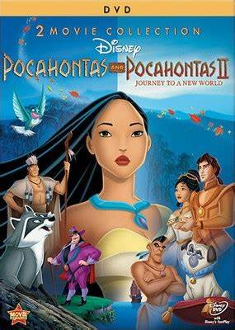
Your first task will be to watch or read the story of Pocahontas
https://www.youtube.com/watch?v=vtjn0yJgqdA

Geography | - Where is Pocahontas set?  - Can you find the country on a map?  - What is the flag of America? Can you draw the flag in your journal book?  - What continent is it on?  - What language do they speak and how do they say hello?
Role-Play | - Which was your favourite part of the story?  - Discuss it with a family member.  - Maybe you could act out your favourite scene from the film!
Science | - Native Americans love nature and really valued to the world around them.  - What do you think we could do to look after the world around us?  - It might be putting rubbish in the bin, recycling, saving electricity!  - Could you design some posters to remind your family about these things?
Literacy | - The Native Americans used to give each other special names like ‘Running Bear’ and Sitting Bull  - Can you write down some names for the members of your family?  - You need to think of an animal or object from nature and add an action to it.  - Remember, when we write names, we use a capital letter for the start of the name!  - I think I would be ‘Sleepy Sloth!
DT | - Dream Catchers were originally created by Native Americans.  - Can you do some research to find out what they are for?  - Can you make one yourself? See the link below for how to make your own dream catcher  - https://parenting.firstcry.com/articles/4-creative-diy-dream-catchers-for-kids/  - https://www.youtube.com/watch?v=-TE0JfKmuGA  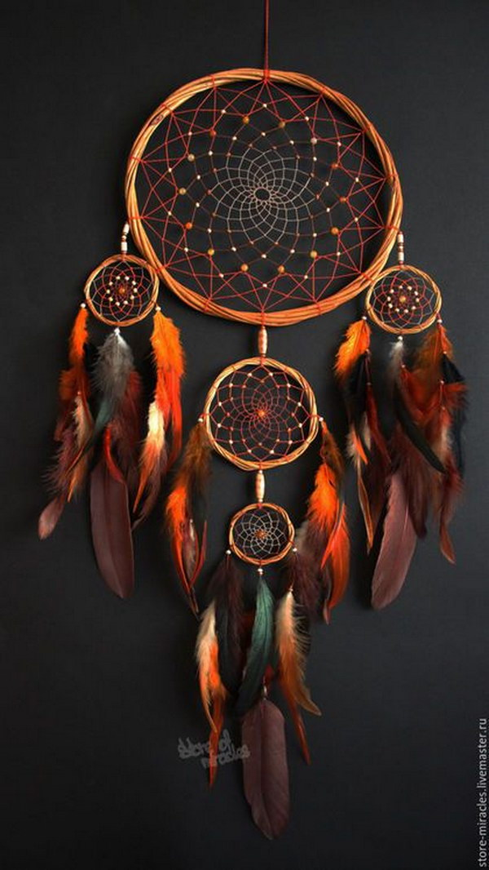
History | - Who were the Native Americans?  - Can you find out something about them?  - Some of them lived in a Tipi – can you draw a Tipi in your books? Maybe you could make one yourself!  - You could make a small one out of paper, or a giant one out of sticks you find in the woods!  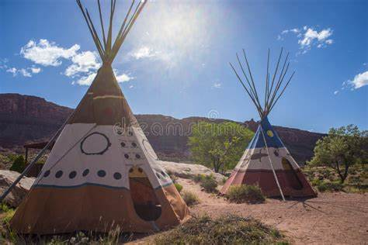
Art | - Can you make your own hand print Native American?  - You will need to decorate it with feathers.  - It doesn’t matter if you don’t have feathers, you can draw these on your own headdress!  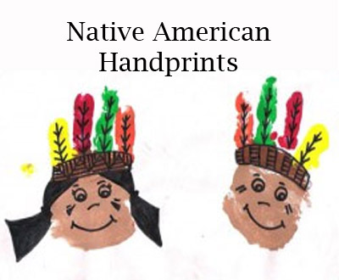
PE | - Pocahontas was really good at creeping around the woods to see what John Smith and his friends were doing.  - Can you teach your family how to play Granny’s Footsteps, and have a go at creeping up on the ‘Granny’  - Remember, be super quiet, don’t be heard!
Music | - Listen to this Native American music (link below)  - Do you know what the instrument is called?  - It’s very relaxing music. Could you get some scarves or light material and have a go at creating a dance to go with it?  - https://www.youtube.com/watch?v=Hjqh1OreXwU
Maths | - Perhaps you could build your own cinema at home. Can you make tickets for your family/teddies?  - Don't forget to number them so you know how many people you are letting in. Look at the number line and make sure you don't have any nosey numbers!  - Now you need to sell your tickets. How much are you going to charge? Concentrate on 1p, 2p, 5p, 10p
PSHE | - The moral of this film is seeing that people are not the same as each other. We are all unique and special in our own way.  - What makes you special?  - Discuss with your family things that make you ‘you’!

