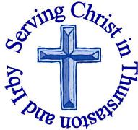
The Churches of
St Bartholomew and St Chad
Thurstaston and Irby
11th June

Welcome to Church today.
We hope that you enjoy the service and gain a sense of God’s presence with us.

Children are Welcome at our Services
In St Chad’s, we have activity bags available and there is also a box of toys and cushions in the foyer, in case you feel your child would be happier playing there.
In St Bartholomew’s, there are some colouring sheets and toys at the back of church.
Children from age 2½ can attend Junior Church (term time) at St Chad’s
Collect  Holy God, faithful and unchanging:  enlarge our minds with the knowledge of your truth,  and draw us more deeply into the mystery of your love,  that we may truly worship you,  Father, Son and Holy Spirit,  one God, now and for ever.  Amen | Post-Communion Prayer  Almighty and eternal God,  you have revealed yourself as Father, Son and Holy Spirit, and live and reign in the perfect unity of love: hold us firm in this faith, that we may know you in all your ways and evermore rejoice in your eternal glory, who are three Persons yet one God,  now and for ever..  Amen

FOR OUR PRAYERS THIS WEEK
For the World: Please continue to pray for all those affected by the terror attacks and for the recently elected Prime Minister.
For the sick: Please continue to pray for baby Tobias (and his parents Katy and Isaac), Joel Murray , Anna Drysdale and Alison Harris. Please pray for those in hospital.
For the bereaved: For the family and friends of Miles Cowie and Joan Jones (funeral Monday 19th June 2pm at St. Bartholomews)
For the parish: Please pray for John Walkup & Sophie Nieto-Hearn, Graham Crawford & Angela Fling having their Banns read today at St. Bartholomew’s , Also pray for Nyla Esme Hodge Jones getting baptised today.
From the Anglican Prayer Cycle: Those to be ordained priest by Bishop Peter next Saturday and the parishes in which serve, Pray for the ministry given into their charge and for the communities in which they minister
From the Diocesan Prayer Cycle: Bishop Barry Beisner, Northern California (VIII, The Episcopal Church,USA)

Services TODAY – Trinity

8:00 am | Holy Communion | St Bartholomew’s
9.30 am | Holy Communion | St Chad’s
11.15 am | Morning worship | St. Bartholomew’s
12.15pm | Baptism | St. Bartholomew’s
7.15 pm | Multi-Sensory Bible | St. Chad’s (Paul)

Services next week
Wednesday 14th June
10.15 am Holy Communion St Chads

Sunday 18th June – Trinity 1 – Fathers Day
8.00am Holy Communion St Bartholomew’s
9.30am Morning Worship St Chad’s
11.15am Holy Communion St Bartholomew’s

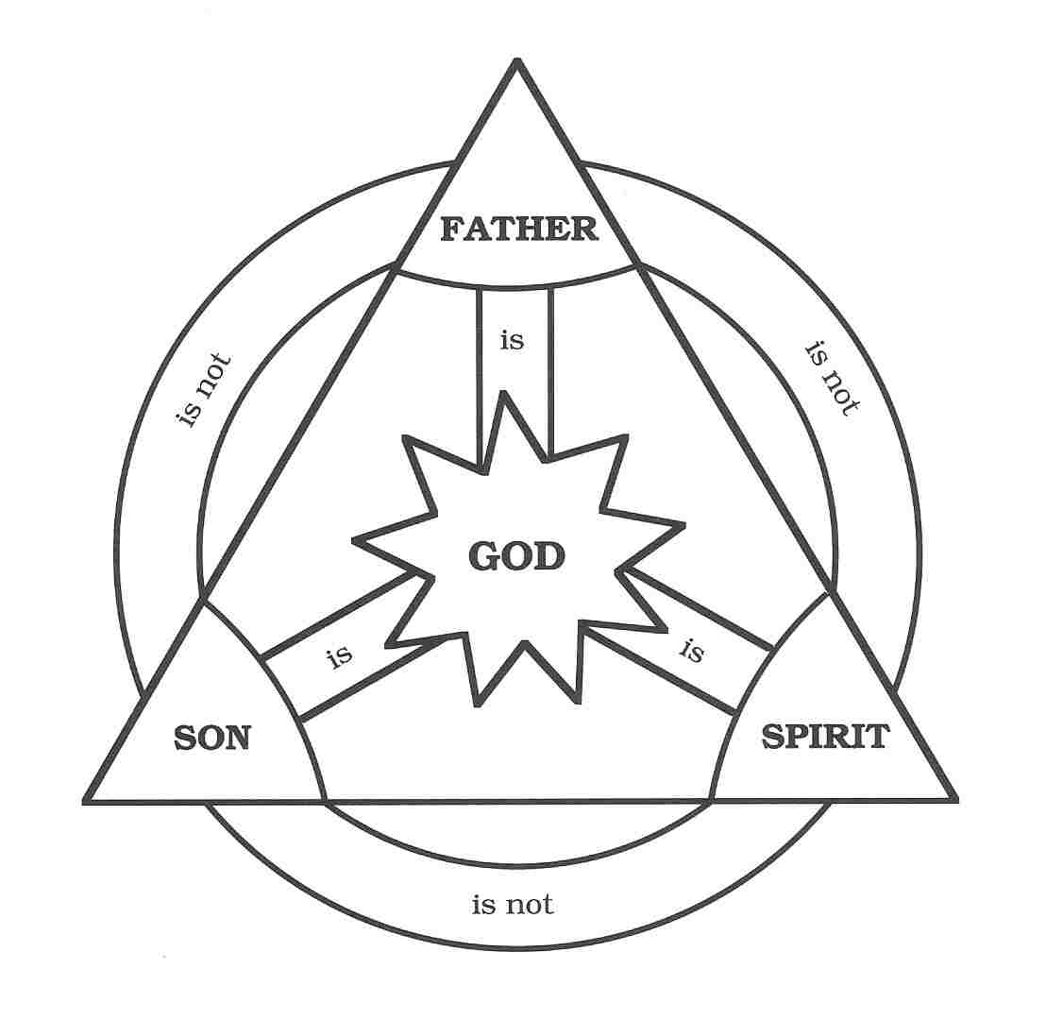

Notices and Announcement

Multi-Sensory Bible - The New Testament: Sundays 7.15 - 8.45pm St Chad’s. Everyone Welcome
June 11th Paul
June 18th The early church
June 25th Jesus return

Saturday 24th June 10am – 12 noon St. Chads
The Foresters Horn Group Riding for the Disabled are having a BOOKS, BAGS, BANGLES and BEADS event. Please donate and come and buy, there will be a raffle and refreshments. Tickets £1

Saturday Together June 24th at St Chad’s 5.30-6.30pm: Come along and join in with the Quizzes, Games, Music, Food, Drinks, Prayer, and Fellowship etc. Great fun for everyone!
Wellspring – 8pm at the Rectory Mon 26th June – Come and pray for our parish. All Welcome – you do not have to pray out loud!

EMU – Wednesday 28th June 8pm St. Chads
We are being visited by R.E.A.C.H sled dogs. Everyone (Men and Women) is invited to come and meet the dogs, rescue team and to hear about their work and activities.

Community Choir this has changed hands and we are now run by VOX. They are a group of 3 ladies and a man. Mostly the twin ladies teach us. It’s a lot of fun, it's very relaxed and we sing a great variety of songs. It's £5 a session and it’s between 8 and 9.30pm every Tuesday evening, except the third Tuesday. Please speak to Julie DeBoorder or see the magazine article for more information

Men’s Breakfast on Saturday 1st July 8.45am-9.45am at Aroma Café Irby. Eat, chat and share in fellowship.

Revd Jane was ordained priest on 28th June 1997 to celebrate the 20th Anniversary of this there will be a special service in Eccles Parish Church at 11.00 am on Sunday 2nd July 2017 followed by a bring and share buffet lunch. We have booked a 35 seater coach (£10.00 per person). Seats will be allocated on a first come first served basis. There is a signup sheet at the back of Church – please add your name and give your £10.00 to Revd Jane (in a clearly marked envelope) ASAP. Departure from the Rectory at 9.30 am. Departure from Eccles at approximately 2.30 pm

Would you like to receive this notice sheet every week direct to your email in-box? If so, please send an email request to the parish office (office@thurstaston.org.uk)

GOSPEL READING: Matthew 28:16-20

All: Glory to you, O Lord

The Commissioning of the Disciples
¹⁶ Now the eleven disciples went to Galilee, to the mountain to which Jesus had directed them. ¹⁷ When they saw him, they worshiped him; but some doubted. ¹⁸ And Jesus came and said to them, “All authority in heaven and on earth has been given to me. ¹⁹ Go therefore and make disciples of all nations, baptizing them in the name of the Father and of the Son and of the Holy Spirit, ²⁰ and teaching them to obey everything that I have commanded you. And remember, I am with you always, to the end of the age.”

All: Praise to you, O Christ

Readings for Today  Is 40:12-17, 27-31  2 Cor 13:11-13  Matt 28:16-20 | Readings for 18th June  Ex 19:2-8a  Rom 5:1-8  Matt 9:35-10:8

Church Office: Mrs K Butler, St Chad’s Church, Roslin Road, Irby, CH61 3UH
Open Tuesday, Wednesday, Thursday, 9.30am-12.30pm (term time)
Tel 648 8169. Website: www.thurstaston.org.uk E-Mail: office@thurstaston.org.uk
Revd Jane Turner 648 1816 (Day off Tuesday). E-Mail: rector@thurstaston.org.uk

