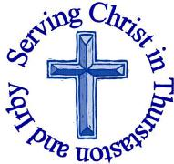
The Churches of
St Bartholomew and St Chad
Thurstaston and Irby
22nd July – Trinity 8
Welcome to Church today.
We hope that you enjoy the service and gain a sense of God’s presence with us.

Children are Welcome at our Services
In St Chad’s, we have activity bags available and there is also a box of toys and cushions in the foyer, in case you feel your child would be happier playing there.
In St Bartholomew’s, there are some colouring sheets and toys at the back of church.
Children from age 2½ can attend Junior Church (term time) at St Chad’s
Collect  Lord God,  your Son left the riches of heaven  and became poor for our sake:  when we prosper save us from pride,  when we are needy save us from despair,  that we may trust in you alone;  through Jesus Christ our Lord.  Amen. |  |  | Post-Communion Prayer  Strengthen for service, Lord,  the hands that have taken holy things;  may the ears which have heard your word  be deaf to clamour and dispute;  may the tongues which have sung your praise be free from deceit;  may the eyes which have seen the tokens of your love shine with the light of hope;  and may the bodies which have been fed with your body be refreshed with the fullness of your life; glory to you for ever.  Amen
FOR OUR PRAYERS THIS WEEK

For the World: God of love, turn our hearts to your ways, and give us peace.
For the Parish: Please pray for Oliver Harris and Lauren Woosey who are getting married on Saturday 28th July at St Bartholomew’s.
For the sick: Please pray for Mark Dennison, Graham Barley, David Cunnington, Anna Drysdale and Christopher Todd. Please pray for those in hospital.
For the Bereaved: Family and friends of Mabel Gardner (Funeral 10.15am Friday 27th July at St Bartholomew’s)
From the Diocesan Prayer Cycle Pray for those made deacon today at Chester Cathedral , for their families, their friends and those among whom they will serve
From the Anglican Prayer Cycle Bishop Juan David Alvarado Melgar, El Salvador (Central America)
Services TODAY Trinity 8
8:00 am | Holy Communion | St. Bartholomew’s
9.30 am  11.15 am | Family Holy Communion  Holy Communion | St Chads  St Bartholomew’s

Services next week

Wednesday 25th July
10.15 am Holy Communion St Chads

Sunday 29th July – Trinity 9

8.00 am Holy Communion St Bartholomew’s
9.30 am Baptism St Chads
11.15 am Baptism St Bartholomew’s

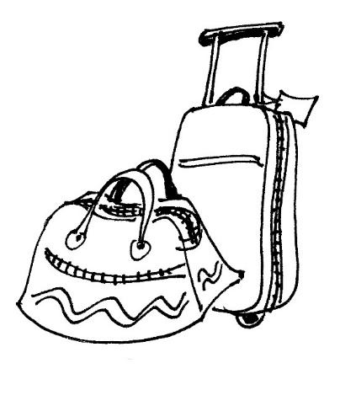

GDPR – Data Protection
If you have received a letter from us regarding this, please return it ASAP. If you do NOT return it, we will be unable to keep in contact with you by post/phone or email

Notices and Announcement

Open House at the Rectory: Revd Jane will be at home on the following days and would like to invite anyone to pop in for a drink and a biscuit (maybe even a piece of cake if you’re lucky!)
Wed 1st August 7-9pm
Thurs 9th August 10am-12 noon
Wed 15th August 7-9pm
Wed 22nd August 7-9pm
For chair and refreshment purposes it would help to know how many people will come, if you could sign on the list at the back of church that would be really helpful. But you are welcome to come even if you don’t sign on the list!

Visit of MU members from Melanesia – Could you offer hospitality?
18 September to 6 October - If you have a spare twin-bedded room and would be prepared to host a couple of MU members during that period for two or three nights, or maybe longer if you wish, the diocesan MU would love to hear from you as a matter of urgency. Please let Chris Rostock (Tel: 648 1112) know as she will pass your information on.

Wirral Foodbank are short of Tins of Meat, Fish, Vegetables, Fruit and rice pudding, Instant Mash, Squash, UHT Milk, Coffee and Shampoo. They have plenty of Beans and Pasta. Donations can be dropped off at The Warrens Medical Centre; Tesco, Heswall; Sainsbury’s, Upton and Asda, Woodchurch
St Beartholomew’s Day on Saturday 25th August, 2pm-4pm. Bring a teddy, make a parachute and enjoy watching your bear parachute from the tower of St Bartholomew’s. Bring your friends, children, grandchildren. Donations of cakes (on the day) and children’s raffle prizes most welcome. If anyone can help with this event can you please speak to Julie DeBoorder

Lost Castles a massive cultural participation project takes place across the Liverpool City Region. Six huge structures built entirely of cardboard, will be constructed in public places across the region from Thurs 9th – Sun12th August. In Wirral, we will be building a Viking stave church in Ashton Park, West Kirby. From Mon 30th July there are a number of free workshops in West Kirby to get everything prepared, everyone aged 9 and over is welcome. We are also looking for people to join us in Ashton Park on Thurs 9th August to help assemble the church. To find out more and register your interest in joining email cultureteam@wirral.gov.uk for more information about the project visit https://www.lostcastles.co.uk/

The Christian Bookshop Birkenhead, have got a Summer Book Sale, 50% off over 500 Book and CD Titles throughout the month of August

Would you like to receive this notice sheet every week direct to your email in-box? If so, please send an email request to the parish office (office@thurstaston.org.uk)
GOSPEL READING: Mark 6:30-34, 53-56
All: Glory to you, O Lord
Feeding the Five Thousand
³⁰ The apostles gathered around Jesus, and told him all that they had done and taught. ³¹ He said to them, “Come away to a deserted place all by yourselves and rest a while.” For many were coming and going, and they had no leisure even to eat. ³² And they went away in the boat to a deserted place by themselves. ³³ Now many saw them going and recognized them, and they hurried there on foot from all the towns and arrived ahead of them. ³⁴ As he went ashore, he saw a great crowd; and he had compassion for them, because they were like sheep without a shepherd; and he began to teach them many things.

Healing the Sick in Gennesaret
⁵³ When they had crossed over, they came to land at Gennesaret and moored the boat. ⁵⁴ When they got out of the boat, people at once recognized him, ⁵⁵ and rushed about that whole region and began to bring the sick on mats to wherever they heard he was. ⁵⁶ And wherever he went, into villages or cities or farms, they laid the sick in the marketplaces, and begged him that they might touch even the fringe of his cloak; and all who touched it were healed.
All: Praise to you, O Christ
Readings for Today  2 Sam 7:1-14a  Eph 2:11-22  Mark 6:30-34,53-56 | Readings for 29th July  2 Sam 11:1-15  Eph 3:14-21  John 6:1-21

Church Office: Mrs K Butler, St Chad’s Church, Roslin Road, Irby, CH61 3UH
Open Tuesday, Wednesday, Thursday, 9.30am-12.30pm (term time)
Tel 648 8169. Website: www.thurstaston.org.uk E-Mail: office@thurstaston.org.uk
Revd Jane Turner 648 1816 (Day off Tuesday). E-Mail: rector@thurstaston.org.uk

