**Year 5 Weekly Timetable Week Commencing 05.05.25**

**To contact your child’s class teacher, please email** [**schooloffice@dawpool.wirral.sch.uk**](mailto:schooloffice@dawpool.wirral.sch.uk) **or phone 0151 648 3412**

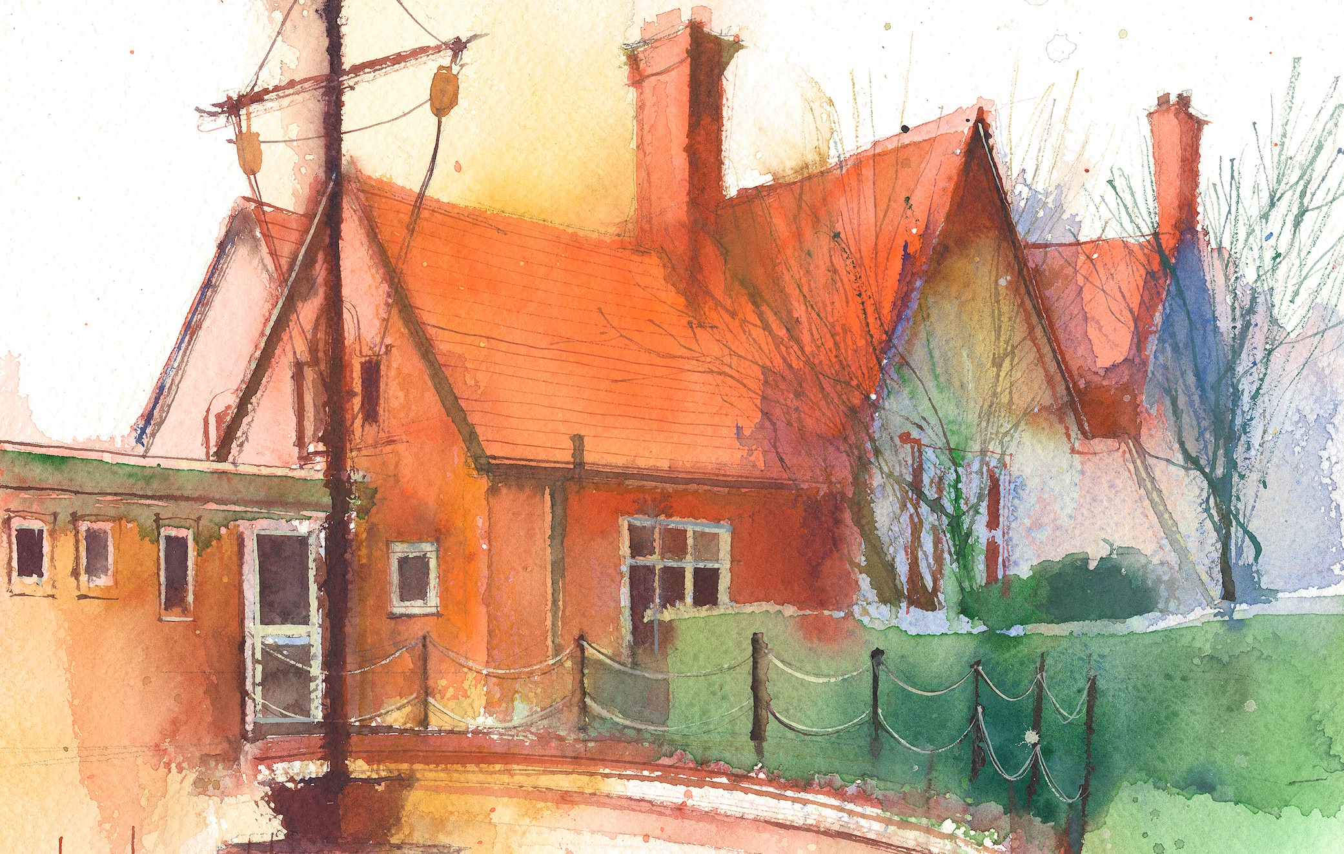

|  |  |  |  |  |  |  |
| --- | --- | --- | --- | --- | --- | --- |
|  | **Lessons 09:00 – 10:30** |  | **Lessons­­­­ 10:45 – 12:15** |  | **Lessons 13:15 – 15:30 (Incorporating 15-minute break)** | **Additional Tasks** |
| **Monday** |  |  |  | Useful Links / Other Recommended Activities  **Oak National Academy**  <https://classroom.thenational.academy/>  **BBC Bitesize**  <https://www.bbc.co.uk/bitesize>  **Purple Mash**  <https://www.purplemash.com/sch/dawpool#/>  **Recommended Reading List**  [See here](https://www.dawpool.wirral.sch.uk/website/recommended_reading_lists/577821) |
| **Tuesday** |  |  |  |
| **Wednesday** | **Year 5 Grammar**  By the end of this lesson your child should be able to:  **To understand that a paragraph is a group of sentences about one main idea. Having paragraphs in descriptions makes it easier for the reader to follow.** | **Year 5 Maths**  By the end of this lesson your child should be able to:  **To understand inverse operations.** | **Year 5 Art – Express Yourself**  By the end of this lesson your child should be able to:  **Create wire models to express body language.**  **Year 5 Music – Liverpool Philharmonic – The World in One City: A Musical Journey**  **Lesson 7 – Aaroh, Avroh**  By the end of this lesson your child should be able to: **·** |
| **Thursday** |  |  | **· play and perform in solo and ensemble contexts, playing musical instruments with increasing accuracy, fluency, control and expression.**  **· improvise and compose music for a range of purposes**  **· use and understand staff and other musical notations. Pupils will create music through improvisation, exploring how to write**  **music for a specific purpose, and they will start to learn more sophisticated compositional techniques and structures.** |
| **Friday** | **Year 5 Reading Comprehension Assessment Spring 2** |  |  |