**Year 4 Weekly Timetable Week Commencing 10.03.25**

**To contact your child’s class teacher, please email** [**schooloffice@dawpool.wirral.sch.uk**](mailto:schooloffice@dawpool.wirral.sch.uk) **or phone 0151 648 3412**

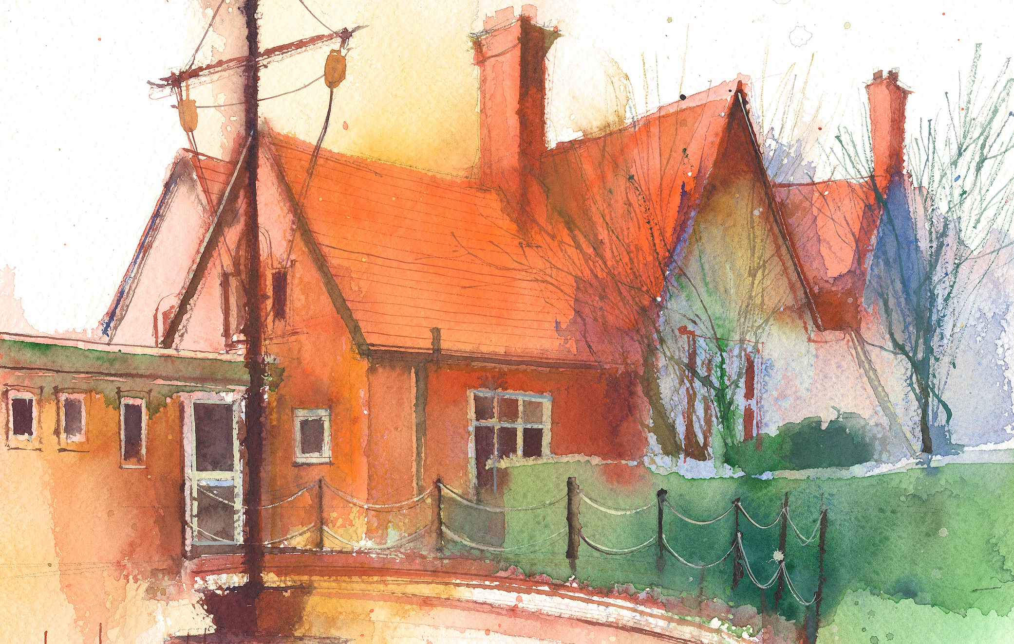

|  |  |  |  |  |  |  |
| --- | --- | --- | --- | --- | --- | --- |
|  | **Lessons 09:00 – 10:30** |  | **Lessons­­­­ 10:45 – 12:15** |  | **Lessons 13:15 – 15:30 (Incorporating 15-minute break)** | **Additional Tasks** |
| **Monday** |  |  |  | Useful Links / Other Recommended Activities  **Oak National Academy**  <https://classroom.thenational.academy/>  **BBC Bitesize**  <https://www.bbc.co.uk/bitesize>  **Purple Mash**  <https://www.purplemash.com/sch/dawpool#/>  **Recommended Reading List**  [See here](https://www.dawpool.wirral.sch.uk/website/recommended_reading_lists/577821) |
| **Tuesday** |  |  |  |
| **Wednesday** |  |  |  |
| **Thursday** | **Year 4 English Reading Comprehension**  By the end of this lesson your child should be able to:  **Understand and respond to the text and answer questions accurately.** | **Year 4 Maths**  By the end of this lesson your child should be able to:  **Know how to find lines of symmetry on shapes.** | **Year 4 Science**  By the end of this lesson your child should be able to:  **To be able to observe that some materials change state when they are heated or cooled, and measure or research the temperature at which this happens in degrees Celsius.**  **To be able to set up a fair test.** |
| **Friday** | **Year 4 ICT – Mr G Lesson 4.1 Coding using Purple Mash 2 Code.**  By the end of this lesson your child should be able to:  **Use coding language and practise creating a simple program** | **Year 4 English**  By the end of this lesson your child should be able to:  **Understand that verbs are doing words. Know how to use the past and perfect tense.**  **Year 4 Maths**  By the end of this lesson your child should be able to:  **Know how to complete a symmetric figure.** | **Year 4 RE Unit 4:5 The Church – Are all churches the same?**  By the end of this lesson your child should be able to:  **Make a list of everything they already know about the Synagogue and Judaism. Watch the video twice. When watching the film for the first time the pupils should listen for the facts they have already remembered and listed, along with facts that the film has reminded them of which they can add to the list. During the second time of watching children to listen for new facts and knowledge.**  **Write three sentences about the job of a rabbi**. |