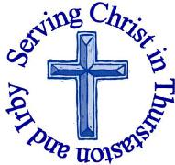
The Churches of
St Bartholomew and St Chad
Thurstaston and Irby
6th October – Trinity 16 - HARVEST

Welcome to Church today.
We hope that you enjoy the service and gain a sense of God’s presence with us.

Children are Welcome at our Services
In St Chad’s, we have activity bags available and there is also a box of toys and cushions in the foyer, in case you feel your child would be happier playing there.
In St Bartholomew’s, there are some colouring sheets and toys at the back of church.
Children from age 2½ can attend Junior Church (term time) at St Chad’s
Collect  Lord of creation,  whose glory is around and within us:  open our eyes to your wonders,  that we may serve you with reverence  and know your peace at our lives’ end,  through Jesus Christ our Lord.  Amen. | Post-Communion Prayer  Almighty God,  you have taught us through your Son  that love is the fulfilling of the law:  grant that we may love you with our whole heart  and our neighbours as ourselves;  through Jesus Christ our Lord.  Amen
FOR OUR PRAYERS THIS WEEK
For the World: Please pray for all those involved in the Brexit negotiations as things change day by day.
For the Parish: Please pray for the work being carried out on the Rectory and for Reverend Jane as she has had to move out.
For the Sick: Please pray for Daffyd Jones-Evans and for all those who are sick at home or in hospital.
From the Diocesan Prayer Cycle: In this harvest season of thankfulness pray for all in the farming sector.
From the Anglican Prayer Cycle: Archbishop John Davies, Archbishop of Wales & Bishop of Swansea & Brecon

Services Today – Trinity 16 - HARVEST

8:00 am | Holy Communion | St. Bartholomew’s
9.30 am  11.15 am | Family Service  Holy Communion | St Chad’s  St Bartholomew’s
Services next week

Wednesday 9th October
10.15 am Holy Communion St Chad’s

Sunday 13th October – Trinity 17
8.00 am Holy Communion St Bartholomew’s
9.30 am Holy Communion St Chad’s
11.15 am Morning Worship St Bartholomew’s

Notices and Announcements

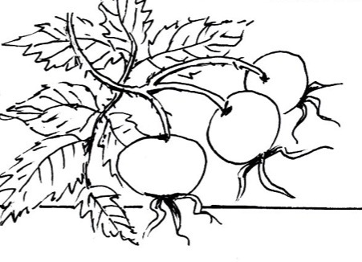

Sidespeople: One of the St Chad’s Team of Sidespeople will be helping in Junior Church from September so we need a new sidesperson. Anyone interested in helping in this way (approximately once a month) should speak to Revd Jane – you need to be fit enough to put chairs out and able to arrive about 9.00am

Saturday, 19th October 2019, 10am - 12noon at Jean Heath's, 'Barnstables', 233 Irby Road All Welcome to a COFFEE MORNING FOR THE CHILDREN'S SOCIETY with Bring & Buy, Craft Stall, Shoe-B-Doo (Continental Shoes and accessories) and Honey Bundles(Gifts for baby showers and newborns).
Please return House Boxes to either Church from September or bring them to the Coffee Morning

Thank you from the Royal Agricultural Benevolent Institution for the kind donation of £83.

Leprosy Mission Boxes – The time has come once more for the collection of your Leprosy Mission Boxes. I would be most grateful to the members of both congregations if you could being your boxes to either church. The boxes will then be collected, emptied and returned to you. Please may I remind all the congregation that a one off donation, put in an envelope marked Leprosy Mission, can be given at any time of the year. Pat Hulme (0151 538 1953)

Dawpool Open Afternoons: Parents who would like their child to join our Foundation 1 (year before reception) or Foundation 2 (reception) class in September 2020 are invited to attend one of our open afternoons in November and December. Please contact the school office to book your appointment on 0151 648 3412. We look forward to meeting you.

Christmas Fair: We need someone to organise the Christmas Fair which is our only major community fund raising event each year. It is currently pencilled into the church diary for Saturday 30th November, but it will only take place if an individual or small group of people agree to organise it. You will have the freedom to run it how you choose – this could be as it’s been in the past (in which case Julie DeBoorder would be willing to share with you the wisdom and knowledge she has gained over many years) or it could be in a completely new form. Please speak to Revd Jane if this is something that you could take on.

Crosstalk – October magazine now available

EMU – Wednesday 16th October –will be meeting at St. Stephens Church, Prenton at 7.30pm, to listen to a talk by Joan Colwell (Mothers’ Union Action and outreach).

Would you like to receive this notice sheet every week direct to your email in-box? If so, please send an email request to the parish office (office@thurstaston.org.uk)
GOSPEL READING: Luke 12:16-21

All: Glory to you, O Lord
¹⁶ And he told them this parable: “The ground of a certain rich man yielded an abundant harvest. ¹⁷ He thought to himself, ‘What shall I do? I have no place to store my crops.’
¹⁸ “Then he said, ‘This is what I’ll do. I will tear down my barns and build bigger ones, and there I will store my surplus grain. ¹⁹ And I’ll say to myself, “You have plenty of grain laid up for many years. Take life easy; eat, drink and be merry.”’
²⁰ “But God said to him, ‘You fool! This very night your life will be demanded from you. Then who will get what you have prepared for yourself?’
²¹ “This is how it will be with whoever stores up things for themselves but is not rich toward God.”

All: Praise to you, O Christ

Readings for 6th October  Deut 24:19-end  James 2:14-22  Luke 12:16-21 | Readings for 13th October  2 Kgs 5:1-3,7-15c  2 Tim 2:8-15  Luke 17:11-19

Church Office: Mrs K Butler, St Chad’s Church, Roslin Road, Irby, CH61 3UH
Open Tuesday, Wednesday, Thursday, 9.30am-12.30pm (term time)
Tel 648 8169. Website: www.thurstaston.org.uk E-Mail: office@thurstaston.org.uk
Revd Jane Turner 648 1816 (Day off Tuesday). E-Mail: rector@thurstaston.org.uk

