LB Weekly Timetable Week Commencing 22.4.24
To contact your child’s class teacher, please email schooloffice@dawpool.wirral.sch.uk
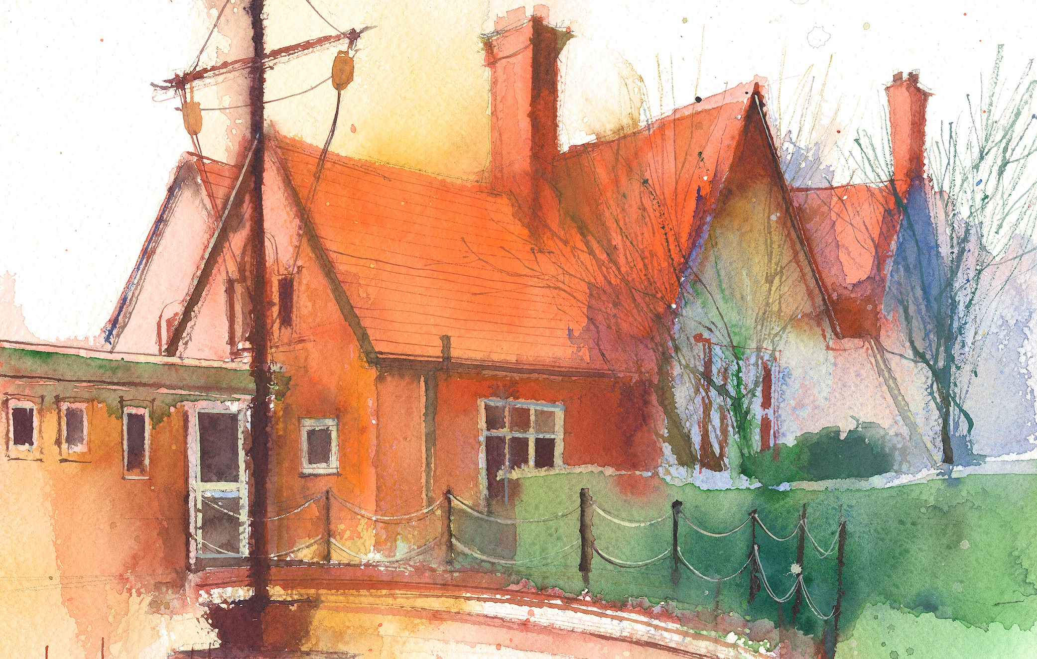

This timetable is available in the event that a Year 6 pupil is required to self-isolate at home, but the cohort remains open to other pupils.
Please visit the Year 6 Remote Learning Page on the school website to access any downloadable resources and activity sheets.

 | Session 1: 09:00-10:30 |  | Session 2: 10:45 – 12:15 |  | Session 3: 13:15 – 15:30 (Incorporating 15-minute break) | Additional Tasks
Monday  22.4.24 | Roman Trip to Chester |  | Roman Trip to Chester |  | History  Roman Trip to Chester
Tuesday  23.4.24 | Power of Reading  By the end of this lesson your child should be able to:  - Collaborate with a group to create a poem about a characters experience.  - Use powerful adjectives to create strong imagery.  - Edit for effect. |  | Music  By the end of this lesson your child should be able to:  - Delivered by a music teacher. |  | - Assembly practice
Wednesday  24.4.24 | Power of reading  By the end of this lesson your child should be able to:  - Collaborate with a group to create a poem about a characters experience.  - Use powerful adjectives to create strong imagery.  - Edit for effect. |  | Maths  By the end of this lesson your child should be able to:  - Know how to divide 1 digit numbers by 10. |  | - Assembly practice

