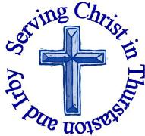
The Churches of
St Bartholomew and St Chad
Thurstaston and Irby
23rd July

Welcome to Church today.
We hope that you enjoy the service and gain a sense of God’s presence with us.

Children are Welcome at our Services
In St Chad’s, we have activity bags available and there is also a box of toys and cushions in the foyer, in case you feel your child would be happier playing there.
In St Bartholomew’s, there are some colouring sheets and toys at the back of church.
Children from age 2½ can attend Junior Church (term time) at St Chad’s
Collect  Creator God,  you made us all in your image:  may we discern you in all that we see,  and serve you in all that we do;  through Jesus Christ our Lord  Amen | Post-Communion Prayer  God of our pilgrimage,  you have led us to the living water:  refresh and sustain us  as we go forward on our journey,  in the name of Jesus Christ our Lord  Amen

FOR OUR PRAYERS THIS WEEK

For the World: Please pray for those still impacted by the tower block fire and terror incidents, and those seeking to help them.
For the sick: Please continue to pray for baby Tobias (and his parents Katy and Isaac), Anna Drysdale, Eira Jones and Alison Harris. Please pray for those in hospital.
For the parish: Pray for Children and Young People at this time of transition at the end of the School year. Please pray for Tony Kendrick and Emily Forshaw as they get married on Saturday 29th July, Also pray for the parents and Godparents of Brandon Lamb and James Bark as they are Baptised later today.
From the Anglican Prayer Cycle: Pray for the work of the RHS and all who work in horticulture – both professionally and as amateurs.
From the Diocesan Prayer Cycle: Bishop Humphrey Olumakaiye, Osun North East (Ibadan, Nigeria)
Services TODAY – Trinity 6

8:00 am | Holy Communion | St Bartholomew’s
9.30 am | Family Holy communion | St Chad’s
11.15 am | Holy Communion | St. Bartholomew’s
3.00pm | Baptism | St Bartholomew’s

Services next week
Wednesday 26th July
10.15 am Holy Communion St Chads

Sunday 30th – Trinity 7

8.00am Holy Communion St Bartholomew’s
9.30am Family Holy Communion St Chad’s
11.15am Baptism St Bartholomew’s

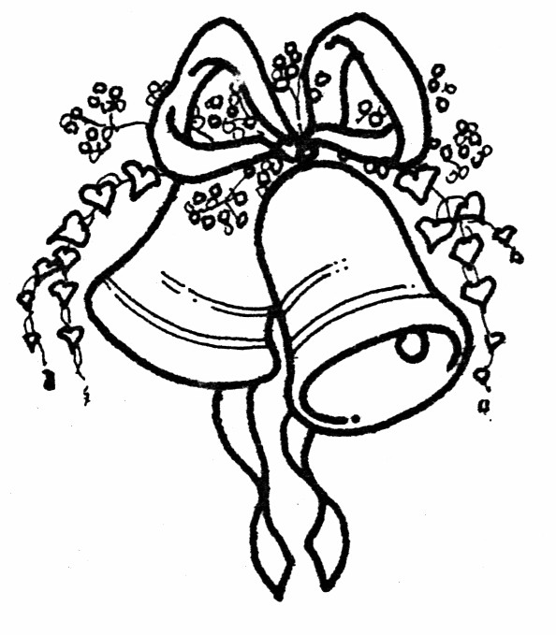

Notices and Announcement

Can you help with some maintenance of St Chad’s Building? We will be shutting the building from Mon 21st August – Sat 2nd Sept so that routine maintenance, painting, cleaning, etc. can be done. If you can help in any way please let Chris Perry or Revd Jane know. Thanks.

Meeting with David Burrows, Head Teacher Dawpool Primary – Julie recently met with David as part of the outreach and mission committee, to explore any needs the school had that the church could meet, as an opportunity to create stronger links with the school. Some of the areas that could be an option are:
After School craft club.
Helping children plan an act of worship
Lunchtime knitting club. Extra adult stayover at year 5 Barnstondale weekend.
If anyone is interested in any of these please contact Julie De Boorder (DBS check will be required). For the Barnstondale weekend please let her know ASAP.

Saturday 26th August 2pm- 4pm St Barts -
“St. Beartholomews day”, bring your teddy, make a parachute and watch as they are launched from the Tower !

2nd September 10am – 12 noon Children’s Society Thank You Coffee Morning will be held at “Barnstables”, 233 Irby Road. Children’s Society house boxes can also be returned to both Churches during August and September.

Would you like to receive this notice sheet every week direct to your email in-box? If so, please send an email request to the parish office (office@thurstaston.org.uk)

GOSPEL READING: Matthew 13:24-30, 36-43

All: Glory to you, O Lord

²⁴ He put before them another parable: “The kingdom of heaven may be compared to someone who sowed good seed in his field; ²⁵ but while everybody was asleep, an enemy came and sowed weeds among the wheat, and then went away. ²⁶ So when the plants came up and bore grain, then the weeds appeared as well. ²⁷ And the slaves of the householder came and said to him, ‘Master, did you not sow good seed in your field? Where, then, did these weeds come from?’ ²⁸ He answered, ‘An enemy has done this.’ The slaves said to him, ‘Then do you want us to go and gather them?’ ²⁹ But he replied, ‘No; for in gathering the weeds you would uproot the wheat along with them. ³⁰ Let both of them grow together until the harvest; and at harvest time I will tell the reapers, Collect the weeds first and bind them in bundles to be burned, but gather the wheat into my barn.’”
Jesus Explains the Parable of the Weeds
³⁶ Then he left the crowds and went into the house. And his disciples approached him, saying, “Explain to us the parable of the weeds of the field.” ³⁷ He answered, “The one who sows the good seed is the Son of Man; ³⁸ the field is the world, and the good seed are the children of the kingdom; the weeds are the children of the evil one, ³⁹ and the enemy who sowed them is the devil; the harvest is the end of the age, and the reapers are angels. ⁴⁰ Just as the weeds are collected and burned up with fire, so will it be at the end of the age. ⁴¹ The Son of Man will send his angels, and they will collect out of his kingdom all causes of sin and all evildoers, ⁴² and they will throw them into the furnace of fire, where there will be weeping and gnashing of teeth. ⁴³ Then the righteous will shine like the sun in the kingdom of their Father. Let anyone with ears listen!

All: Praise to you, O Christ

Readings for Today  SofS12:13,16-19  Rom 8:1-11  Matt 13:24-30,36-43 | Readings for 30th July  1 Kings 3:5-12  Rom 8:26-39  Matt 13:31-33,44-52

Church Office: Mrs K Butler, St Chad’s Church, Roslin Road, Irby, CH61 3UH
Open Tuesday, Wednesday, Thursday, 9.30am-12.30pm (term time)
Tel 648 8169. Website: www.thurstaston.org.uk E-Mail: office@thurstaston.org.uk
Revd Jane Turner 648 1816 (Day off Tuesday). E-Mail: rector@thurstaston.org.uk

