**Year 1 Weekly Timetable Week Commencing 31.03.25**

**To contact your child’s class teacher, please email** [**schooloffice@dawpool.wirral.sch.uk**](mailto:schooloffice@dawpool.wirral.sch.uk) **or phone 0151 648 3412**

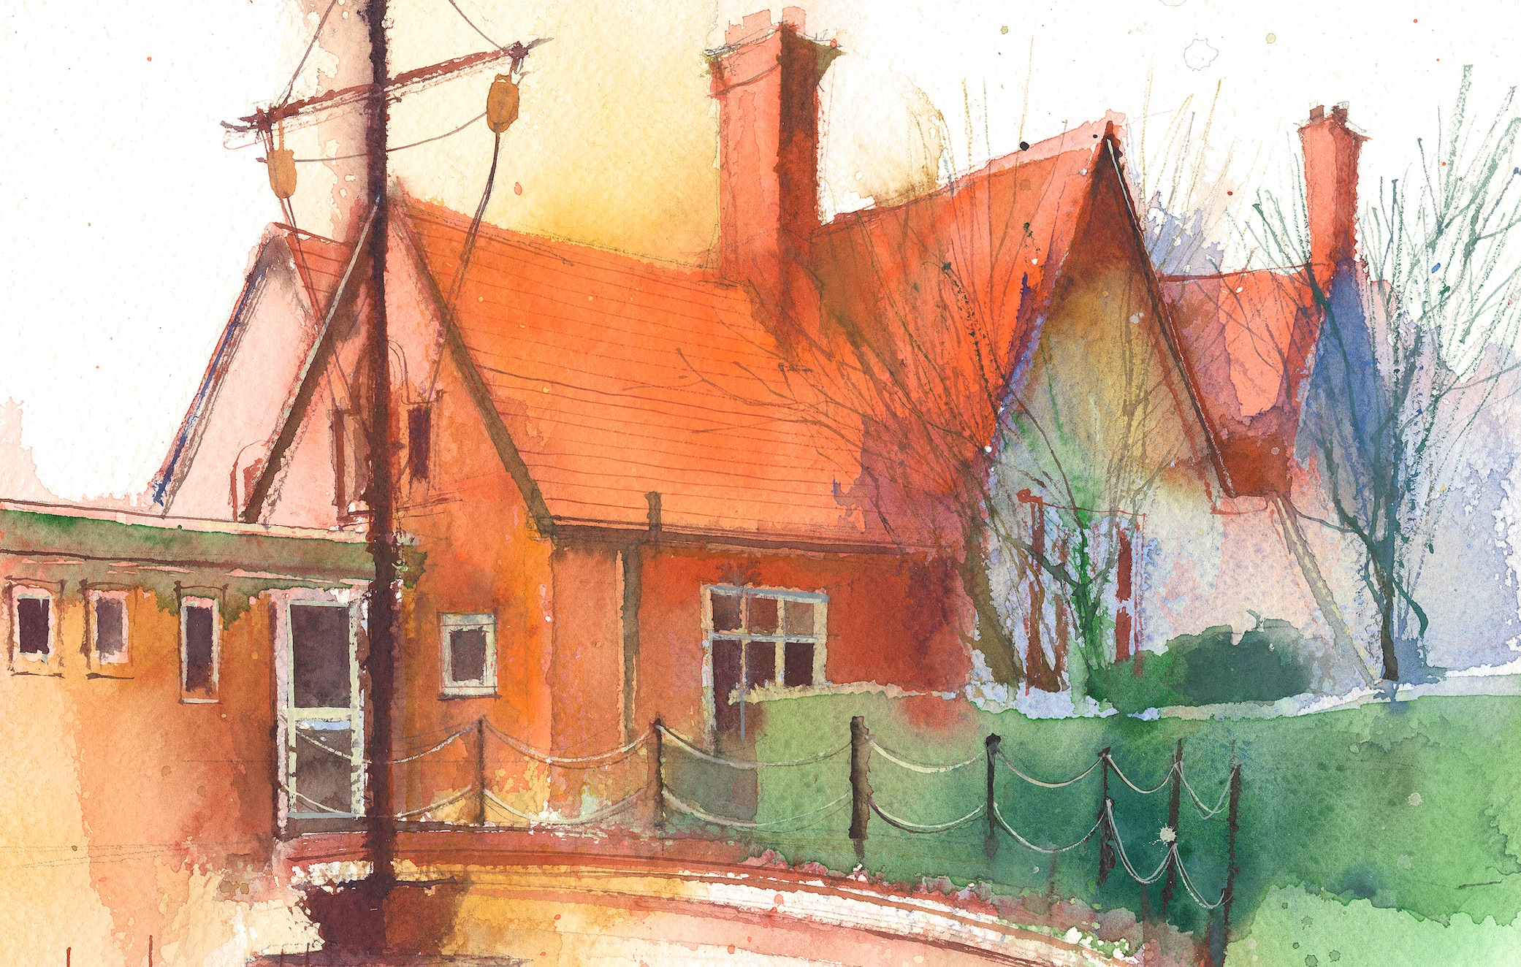

|  |  |  |  |  |  |  |
| --- | --- | --- | --- | --- | --- | --- |
|  | **Lessons 09:00 – 10:30** |  | **Lessons­­­­ 10:45 – 12:15** |  | **Lessons 13:15 – 15:30 (Incorporating 15-minute break)** | **Additional Tasks** |
| **Monday** | **Phonics:** m as mb (blending practice)  **English:** I can introduce the opening to my newspaper report. | **D&T:** To be able to create a sliding mechanism.  **ERIC / GR** | **Fluent in 5**  **D&T:** To be able to use levers to create a moving mechanism.  **My Happy Mind:** Appreciate. | Useful Links / Other Recommended Activities  **Oak National Academy**  <https://classroom.thenational.academy/>  **BBC Bitesize**  <https://www.bbc.co.uk/bitesize>  **Purple Mash**  <https://www.purplemash.com/sch/dawpool#/>  **Recommended Reading List**  [See here](https://www.dawpool.wirral.sch.uk/website/recommended_reading_lists/577821) |
| **Tuesday** | **Phonics:** m as mb (segmenting practice)  **English:** I can write a newspaper report for the whale lying beached in the bay. | **D&T:** To investigate and create wheel mechanisms.  **ERIC / GR** | **Fluent in 5**  **D&T:** To be able to design a picture with a moving mechanism.  **No Outsiders:** Wanna play Trucks? |
| **Wednesday** | **Phonics:** n as kn (blending practice)  **English:** I can write a newspaper report for the whale lying beached in the bay. | **D&T:** To be able to make a moving picture based on a design.  **ERIC / GR** | **Fluent in 5**  **D&T:** To be able to evaluate a moving picture.  **Picture News** |
| **Thursday** | **Phonics:** n as kn (segmenting practice)  **English:** Spag | **Maths:** Know how to compare mass.  **ERIC / GR** | **Fluent in 5**  **Heartsmart:** Don’t hold on to what’s wrong.  **PE:** Exploring dance with Titanic theme. |
| **Friday** |  | **See Mrs Clark’s Planning** |  |