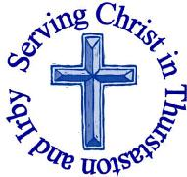
The Churches of
St Bartholomew and St Chad
Thurstaston and Irby
2nd July

Welcome to Church today.
We hope that you enjoy the service and gain a sense of God’s presence with us.

Children are Welcome at our Services
In St Chad’s, we have activity bags available and there is also a box of toys and cushions in the foyer, in case you feel your child would be happier playing there.
In St Bartholomew’s, there are some colouring sheets and toys at the back of church.
Children from age 2½ can attend Junior Church (term time) at St Chad’s
Collect  God our saviour,  look on this wounded world  in pity and in power;  hold us fast to your promises of peace  won for us by your Son,  our Saviour Jesus Christ.  Amen | Post-Communion Prayer  O God, whose beauty is beyond our imagining and whose power we cannot comprehend:  show us your glory as far as we can grasp it,  and shield us from knowing more than we can bear until we may look upon you without fear;through Jesus Christ our Saviour..  Amen

FOR OUR PRAYERS THIS WEEK

For the World: Please pray for all those affected by the landslide in China, continue to pray for those affected by the Tower block fire in London, and those affected by the fires in Portugal.
For the sick: Please continue to pray for baby Tobias (and his parents Katy and Isaac), Anna Drysdale , Eira Jones and Alison Harris. Please pray for those in hospital.
For the parish: Please pray for Reverend Jane as she celebrates her 20th Anniversary of Ordination
From the Anglican Prayer Cycle: Pray for those made deacon today, for their families, their friends and those among whom they will serve
From the Diocesan Prayer Cycle: Bishop Festus Davies, Ogori-Magongo (Lokoja, Nigeria) and Bishop Chidi Collins Oparaojiak, Ohaji / Egbema (Owerri, Nigeria)
Services TODAY – Trinity 3

8:00 am | Holy Communion | St Bartholomew’s
9.30 am | Morning Worship | St Chad’s
11.15 am | Holy Communion | St. Bartholomew’s

Services next week
Wednesday 28th June
10.15 am Holy Communion St Chads

Sunday 9th July – Trinity 4

8.00am Holy Communion St Bartholomew’s
9.30am Holy communion St Chad’s
11.15am Morning Worship St Bartholomew’s

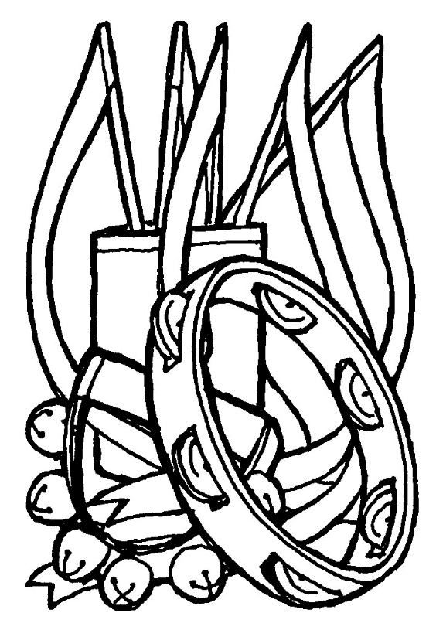

Notices and Announcement

Saturday 15th July 10am – 12 noon “Operation Christmas Child” coffee morning. Shoeboxes will be available for a small charge, Ray Ward will be showing a rolling film slide show. Knitting patterns and craft ideas will also be available. Profits will be donated to MU charities. Please come and along and invite your friends, particularly those who have not heard of “Operation Christmas Child”

Sunday 16th July from 11am – Church Picnic at Royden Park. Everyone welcome – bring your friends and family. Bring a picnic a rug/chairs and some games e.g. Frisbee, rounder’s etc. We meet somewhere near the trains.

Book Giving Service Sunday 16th July at St.Chads –there is a football theme to this service and it would be great if everyone could wear an Everton or Liverpool top or alternatively Red or Blue clothes. All the children will get a chance to participate and will receive a book to end the school year.

Saturday Together 22nd July 5.30pm -6.30pm – BBQ, games and quizzes at St Chads, everyone welcome. BBQ provided, please bring your own food to cook.

Can you help with some maintenance of St Chad’s Building? We will be shutting the building from Mon 21st August – Sat 2nd Sept so that routine maintenance, painting, cleaning, etc. can be done. If you can help in any way please let Chris Perry or Revd Jane know. Thanks.

Meeting with David Burrows, Head Teacher Dawpool Primary – Julie recently met with David as part of the outreach and mission committee, to explore any needs the school had that the church could meet, as an opportunity to create stronger links with the school. Some of the areas that could be an option are:
After School craft club.
Helping children plan an act of worship
Lunchtime knitting club.
Extra adult stayover at year 5 Barnstondale weekend.
If anyone is interested in any of these please contact Julie De Boorder (DBS check will be required). For the Barnstondale weekend please let her know ASAP.

Saturday 26th August 2pm- 4pm St Barts -
“St. Beartholomews day”, bring your teddy, make a parachute and watch as they are launched from the Tower !

Would you like to receive this notice sheet every week direct to your email in-box? If so, please send an email request to the parish office (office@thurstaston.org.uk)

GOSPEL READING: Matthew 10:40-42

All: Glory to you, O Lord

Rewards
⁴⁰ “Whoever welcomes you welcomes me, and whoever welcomes me welcomes the one who sent me. ⁴¹ Whoever welcomes a prophet in the name of a prophet will receive a prophet’s reward; and whoever welcomes a righteous person in the name of a righteous person will receive the reward of the righteous; ⁴² and whoever gives even a cup of cold water to one of these little ones in the name of a disciple—truly I tell you, none of these will lose their reward.”

All: Praise to you, O Christ

Readings for Today  Jer 28:5-9  Rom 6:12-23  Matt 10:40-42 | Readings for 9th July  Zech 9:9-12  Rom 7:15-25a  Matt 11:16-19, 25-30

Church Office: Mrs K Butler, St Chad’s Church, Roslin Road, Irby, CH61 3UH
Open Tuesday, Wednesday, Thursday, 9.30am-12.30pm (term time)
Tel 648 8169. Website: www.thurstaston.org.uk E-Mail: office@thurstaston.org.uk
Revd Jane Turner 648 1816 (Day off Tuesday). E-Mail: rector@thurstaston.org.uk

