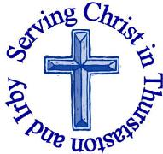
The Churches of
St Bartholomew and St Chad
Thurstaston and Irby
14th July – Trinity 4

Welcome to Church today.
We hope that you enjoy the service and gain a sense of God’s presence with us.

Children are Welcome at our Services
In St Chad’s, we have activity bags available and there is also a box of toys and cushions in the foyer, in case you feel your child would be happier playing there.
In St Bartholomew’s, there are some colouring sheets and toys at the back of church.
Children from age 2½ can attend Junior Church (term time) at St Chad’s
Collect  Gracious Father,  by the obedience of Jesus you brought salvation to our wayward world:  draw us into harmony with your will,  that we may find all things restored in him,our Saviour Jesus Christ.  Amen. | Post-Communion Prayer  Eternal God,  comfort of the afflicted and healer of the broken, you have fed us at the table of life and hope:  teach us the ways of gentleness and peace, that all the world may acknowledge  the kingdom of your Son Jesus Christ our Lord.  Amen
FOR OUR PRAYERS THIS WEEK
For the World: Please pray for all those affected by the heat wave across Europe.
For the Parish: Please pray for Journey into Light preparations
For the Sick: Please pray for Lil and Karen Ormsby, Dorothy Joyce, Pam Ward (Daughter of Dorothy Joyce), Mandy Fletcher, Maureen Noonan, Emma Parmenter and for all those who are sick at home or in hospital.
From the Diocesan Prayer Cycle: Pray that we may be an inclusive and enabling church.
From the Anglican Prayer Cycle: Bishop Rayford Ray, Northern Michigan (The Episcopal Church, USA),Bishop Alfred Patterson Worek, Banks and Torres (Vanuatu), Bishop Joseph Abura, Karamoja (Uganda)

Would you like to receive this notice sheet every week direct to your email in-box? If so, please send an email request to the parish office (office@thurstaston.org.uk)

Services Today – Trinity 4

8:00 am | Holy Communion | St. Bartholomew’s
9.30 am  11.15 am | Holy Communion  Morning Worship | St Chad’s  St Bartholomew’s
Services next week

Wednesday 17th July
10.15 am Holy Communion St Chad’s

Sunday 21st July – Trinity 5
8.00 am Holy Communion St Bartholomew’s
9.30 am Morning Worship St Chad’s
11.15 am Holy Communion St Bartholomew’s

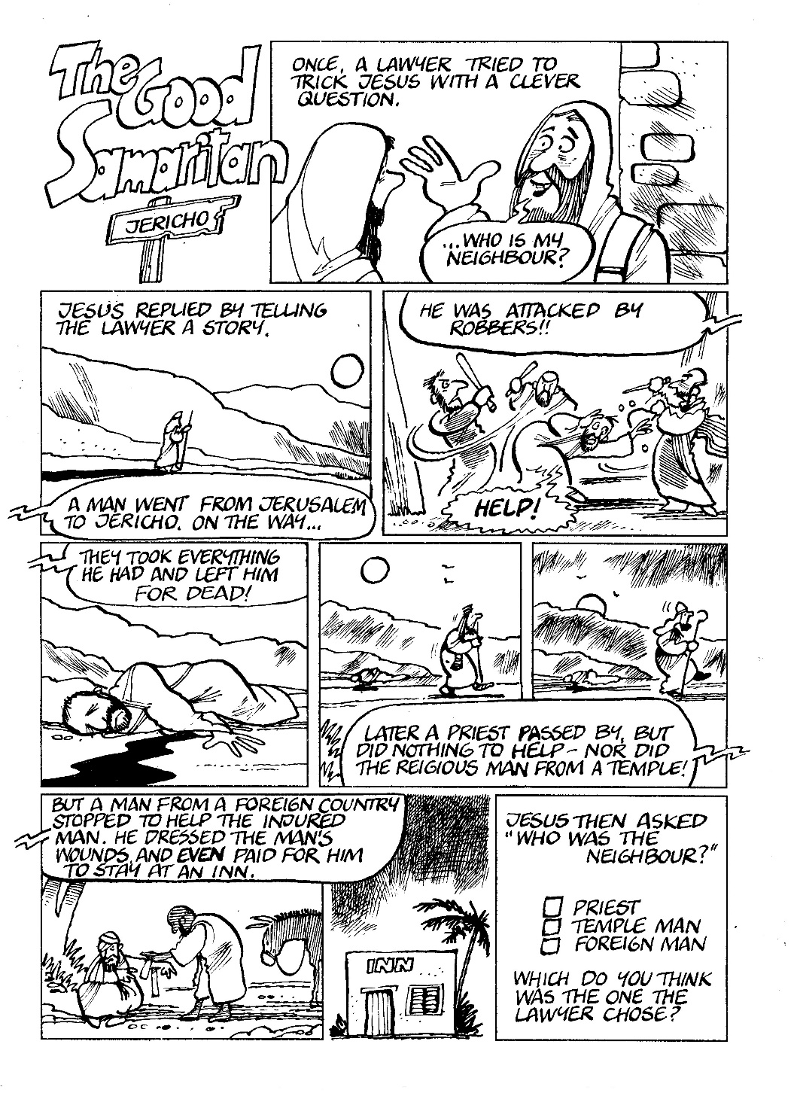
Notices and Announcements

The Wisdom House – 8-9pm St Chad’s Extension Each session is totally independent of the others. So choose which ones you want to come to. You are of course welcome to come to all of them.
Mon 15th July - Living a life true to yourself
At times we can find ourselves trying to be somebody that we just can’t be. This session encourages us to recognise when we are living our lives in an attempt to meet someone else’s expectations and encourages us to play to our strengths.
Wed 31st July - The long walk home
The story of the prodigal son will prompt discussion on jealousy between siblings, forgiveness from parents, and whether it is always right to welcome the ‘wanderer’ back. It also explores the idea of God as a Father waiting for us to come home.
Wed 7th August- Thieves of Joy
Hankering after the past or longing for a better future - both will steal your present joy. This session looks at finding contentment and grasping happiness now

Junior Church – Helpers and Leaders: Many thanks to Elizabeth, Julie and Jane who have offered to join the team from September. Anyone else who would be willing to help please speak to Julie DeBoorder, the more we have, the less often you need to help.

Sidespeople: One of the St Chad’s Team of Sidespeople will be helping in Junior Church from September so we need a new sidesperson. Anyone interested in helping in this way (approximately once a month) should speak to Revd Jane – you need to be fit enough to put chairs out and able to arrive about 9.00am.

Wirral Foodbank, the list of urgently needed items are : tinned meat, tinned fish, pasta sauce, sugar, sponge pudding, biscuits, packet soup, long grain rice, uht milk, custard, deodorant. They have plenty of beans and tea.

Crosstalk and Rotas- July/August magazine is now available in church August/September/October rota’s are also available to pick up.

Journey into Light Art Exhibition: We are hosting this exhibition at St Chad’s from Fri 16th – Mon 19th August and need volunteers to “person” the building and serve refreshments (tea/coffee) to visitors. If you can help, please speak to Julie DeBoorder, Julie Parmenter or Revd Jane, or sign the sheet at the back of church.
Journey Into Light is an exhibition of art work created by prisoners from HMP Styal and HMP Thorn Cross, Cheshire. The aim of the exhibition is to demonstrate the lived experience of prisoners and the stories behind their convictions and sentences. The hope is that by seeing the creativity of prisoners and hearing their stories people will be able to better understand some of the choices, mistakes and circumstances that they have faced in their lives.

Foxhill - Life in the Spirit Wednesday 11th September 4pm – Friday 13th Sept 2pm.
We will look at what it means to pray ‘Come Holy Spirit’ day by day, and how we can trace His presence and provision in the different seasons and experiences of life. The cost is £170 pp – includes en-suite accommodation meals & refreshments. This can be booked on the Twenty is Plenty scheme for more information go to https://www.foxhillchester.co.uk/whats-on/twenty-is-plenty/ to book contact Foxhill on 01928 733777

Parish Pixels is a national photography competition for Anglican Churches. Prize of £5,000 to the winning church. If you would like to submit an entry on behalf of St Bartholomew’s or St Chad’s then please pick up a flyer from church or take a look at our website for more details.www.thurstaston.org.uk

GOSPEL READING: Luke 10:25-37

All: Glory to you, O Lord
²⁵ On one occasion an expert in the law stood up to test Jesus. “Teacher,” he asked, “what must I do to inherit eternal life?”
²⁶ “What is written in the Law?” he replied. “How do you read it?”
²⁷ He answered, “‘Love the Lord your God with all your heart and with all your soul and with all your strength and with all your mind’ and, ‘Love your neighbor as yourself.’”
²⁸ “You have answered correctly,” Jesus replied. “Do this and you will live.”
²⁹ But he wanted to justify himself, so he asked Jesus, “And who is my neighbor?”
³⁰ In reply Jesus said: “A man was going down from Jerusalem to Jericho, when he was attacked by robbers. They stripped him of his clothes, beat him and went away, leaving him half dead. ³¹ A priest happened to be going down the same road, and when he saw the man, he passed by on the other side. ³² So too, a Levite, when he came to the place and saw him, passed by on the other side. ³³ But a Samaritan, as he traveled, came where the man was; and when he saw him, he took pity on him. ³⁴ He went to him and bandaged his wounds, pouring on oil and wine. Then he put the man on his own donkey, brought him to an inn and took care of him. ³⁵ The next day he took out two denarii and gave them to the innkeeper. ‘Look after him,’ he said, ‘and when I return, I will reimburse you for any extra expense you may have.’
³⁶ “Which of these three do you think was a neighbor to the man who fell into the hands of robbers?”
³⁷ The expert in the law replied, “The one who had mercy on him.”
Jesus told him, “Go and do likewise.”

All: Praise to you, O Christ
Readings for Today  Deut 30:9-14  Col 1:1-14  Luke 10:25-37 | Readings for 21st July  Gen 18:1-10a  Col 1:15-28  Luke 10:38-end
Church Office: Mrs K Butler, St Chad’s Church, Roslin Road, Irby, CH61 3UH
Open Tuesday, Wednesday, Thursday, 9.30am-12.30pm (term time)
Tel 648 8169. Website: www.thurstaston.org.uk E-Mail: office@thurstaston.org.uk
Revd Jane Turner 648 1816 (Day off Tuesday). E-Mail: rector@thurstaston.org.uk

