Foundation 1 -phase 1 phonics
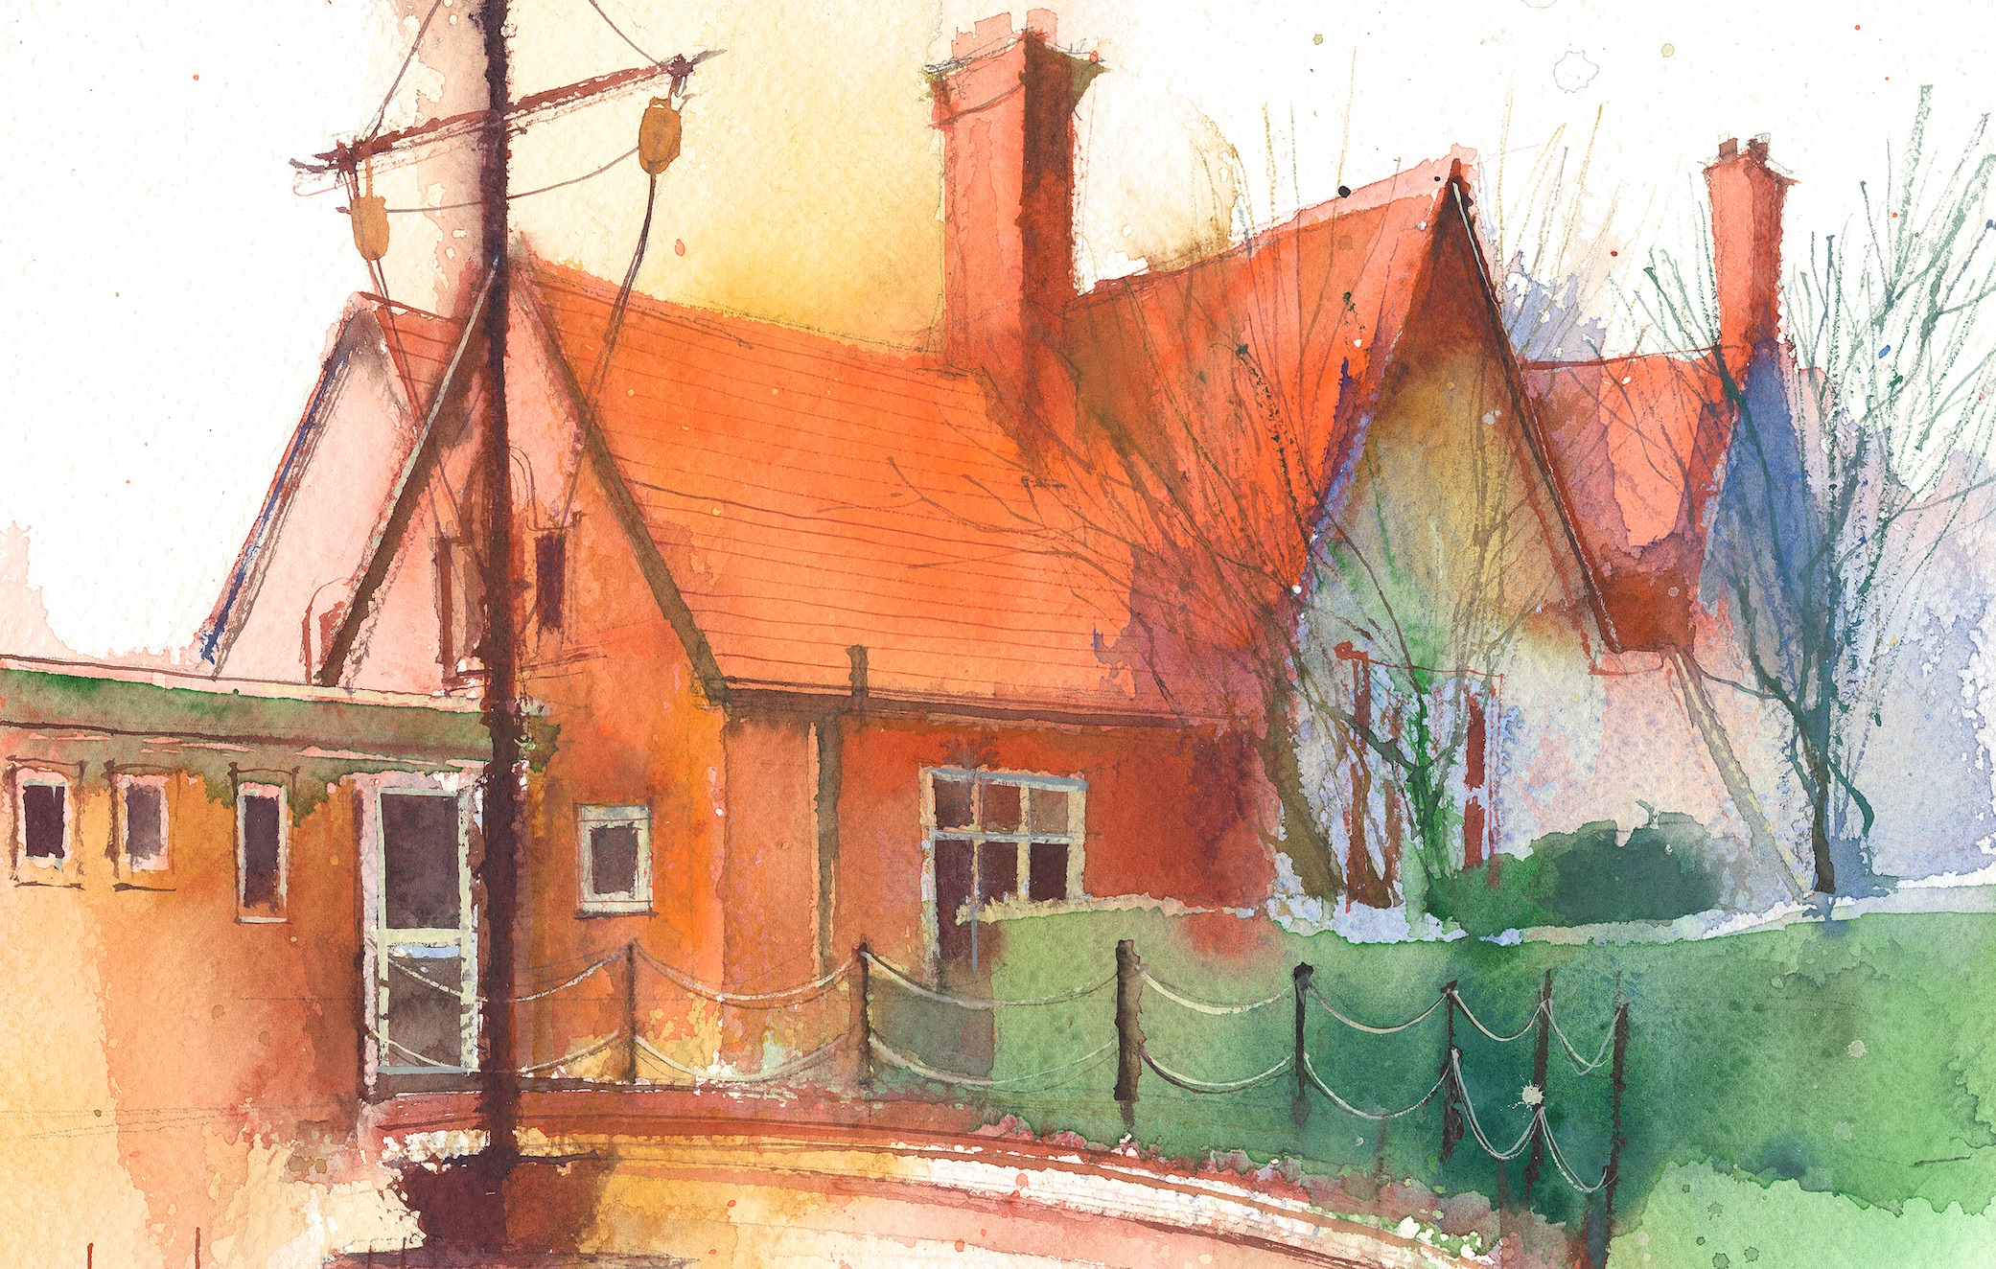

Phase 1: Aspect 2: General Sound Discrimination - Instrumental Sounds
Main Purpose: To experience and develop awareness of sounds made with instruments and noise makers.
To listen to and appreciate the difference between sounds made with instruments.

Revisit/ Review | Revise sitting and listening skills.  Learning cards. | Revise sitting and listening skills.  Learning cards. | Revise sitting and listening skills.  Learning cards. | Revise sitting and listening skills.  Learning cards. | Revise sitting and listening skills.  Learning cards.
Teach | Tuning into sounds  Show children two sets of musical instruments and name them. Play each instrument, whilst children listen.  Then hide one set.  Demonstrate playing a hidden instrument and the children say the instruments name. | Matching Sound Makers  Show children some musical instruments (2 of each) and place one set in a feely bag.  Adult selects one instrument from the bag, makes the sound and encourages children to match it to the other instrument not in the bag.  Repeat. | Matching Sounds  Sitting in a circle the adult demonstrates playing a percussion instrument. Then explain that we are going to pass the instrument and try to copy the sounds made. | Hidden Instruments  Outside hide some musical instruments for the children to find.  Demonstrate finding one instrument, play it and the children gather round you. | Animal Sounds  Choose an animal puppet and instrument to match. Demonstrate playing all the musical instruments until one is found to match the puppet.
Practise | Repeat activity to consolidate learning. | Then children, one by one, attempt the activity. | Practise this activity, taking it in turns to have a go. | The children find the instruments, play it and run to the finder. | In turn children choose an instrument to match their chosen puppet.
Apply | Children take it in turns to do the activity. | Repeat and discuss sounds made. Correct any misconceptions. | Repeat and support children who are struggling. | Repeat until all instruments found. | Practice playing their musical instrument to the group.

