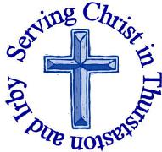
The Churches of St Bartholomew and St Chad
Thurstaston and Irby
22nd December – Advent 4

Welcome to Church today.
We hope that you enjoy the service and gain a sense of God’s presence with us.

Children are Welcome at our Services
In St Chad’s, we have activity bags available and there is also a box of toys and cushions in the foyer, in case you feel your child would be happier playing there.
In St Bartholomew’s, there are some colouring sheets and toys at the back of church.
Children from age 2½ can attend Junior Church (term time) at St Chad’s
Collect  Eternal God,  as Mary waited for the birth of your Son,  so we wait for his coming in glory;  bring us through the birth pangs of this present age  to see, with her, our great salvation  in Jesus Christ our Lord.  Amen. | Post-Communion Prayer  Heavenly Father,  who chose the Blessed Virgin Mary  to be the mother of the promised saviour:  fill us your servants with your grace,  that in all things we may embrace your holy will  and with her rejoice in your salvation;  through Jesus Christ our Lord.  Amen
FOR OUR PRAYERS THIS WEEK
For the World: Please pray for a peaceful time for all.
For the Parish: Please pray for those, missing loved ones at this time of year.
For the Sick: Please pray for Albert den Otter and Samuel Williams (extended family of Linda and Graham Barley), Eric Jones and for all those who are sick at home or in hospital.
For the Bereaved: Please pray for the family and friends of Dorothy Joyce.
From the Diocesan Prayer Cycle Pray for an engaged and engaging celebration of God incarnate.
From the Anglican Prayer Cycle: Pray for Christians in other denominations and the work of the ecumenical movement. His Holiness Pope Francis, Bishop of Rome. His All Holiness Archbishop Bartholomew of Constantinople, New Rome and Ecumenical Patriarch. Bishop Olav Fykse Tveit, General Secretary of the World Council of Churches. Bishop Ivan M Abrahams, General Secretary World Methodist
Council. The Reverend Chris Ferguson, General Secretary of the World
Communion of Reformed Churches.

Services Today – Advent 4

8:00 am | Holy Communion | St. Bartholomew’s
9.30 am  3.00 pm | Nativity  Joint Carol Service | St. Chad’s  St. Bartholomew’s
Please note there is no 11.15am service at St. Bartholomew’s
Services next week

Tuesday 24th December – Christmas Eve
4.00pm Crib Service St Bartholomew’s
5.00pm Crib Service St Bartholomew’s
11.15pm First Communion of Christmas St Bartholomew’s

Wednesday 25th December – Christmas Day
8.00am Holy Communion St Bartholomew’s
10.30am Family Communion St Chad’s

Sunday 29^{th‘}December – Christmas 1

8.00 am Holy Communion St Bartholomew’s
9.30 am Morning Worship St Chad’s
11.15 am Holy Communion St. Bartholomew’s

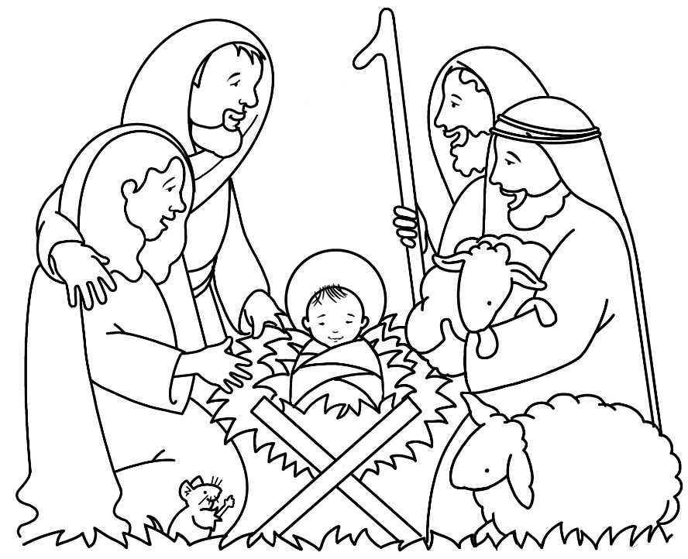

Notices and Announcements

Christmas Greetings from Simon and Joyce Beckley
We have received a Christmas Card which says: “To all of the fellowship of St B and St C, God Bless You at Christmas, Love in the Lord, Simon and Joyce”

Linda Barley is collecting second hand hat, scarves, gloves, ladies handbags and new toiletries to pass to a friend who is collecting for the Charles Thompson Mission, if you can help please pass the items to Linda.

NOTORIOUS: St Chad’s Extension on Thursdays 8.00-9.15pm (9.30pm at the latest!) Everyone Welcome next session 9th January – more details in Parish Magazine. “The Bible is full of men and women who strayed from the path of good: the rogues, scoundrels and scallywags. But is there something good these bad people can teach us? Why not join us as we discover together

Dawpool Admissions – Supplementary forms. If you require Revd Jane to sign one of these forms please hand it to her or deliver it to the Rectory. Revd Jane will deliver to school (by hand) on Monday 6th January.

Service Booklets: Could you help to repair some of our service booklets? It just needs some of your time and a roll of sellotape! If you can help, please take a box of books home (from the cupboard at St Chad's, or speak to Liz at St Bart’s), do the repair job and bring them back. We are currently using the purple Advent ones, so please don't take them. Thank you for your support.

Wirral Foodbank urgently need uht milk Instant mash, Packet soup, Coffee/hot chocolate, Sponge puddings, Tinned fruit, Tinned custard, Squash/juice, Sugar (small if possible),Toothpaste, Washing up liquid they have plenty of beans. Food can be donated at Asda, Sainsbury’s, most co-op stores and the library.

Readings for 22th December  Is 7:10-16  Rom 1:1-7  Matt 1:18-25 | Readings for 29th December  Is 63:7-9  Heb 2:13-23  Matt 2:13-23
Church Office: Mrs K Butler, St Chad’s Church, Roslin Road, Irby, CH61 3UH
Open Tuesday, Wednesday, Thursday, 9.30am-12.30pm , now closed until 7th January
Tel 648 8169. Website: www.thurstaston.org.uk E-Mail: office@thurstaston.org.uk
Revd Jane Turner 648 1816 (Day off Tuesday). E-Mail: rector@thurstaston.org.uk
GOSPEL READING: Matthew 1:18-25

All: Glory to you, O Lord

¹⁸ This is how the birth of Jesus the Messiah came about: His mother Mary was pledged to be married to Joseph, but before they came together, she was found to be pregnant through the Holy Spirit. ¹⁹ Because Joseph her husband was faithful to the law, and yet did not want to expose her to public disgrace, he had in mind to divorce her quietly.
²⁰ But after he had considered this, an angel of the Lord appeared to him in a dream and said, “Joseph son of David, do not be afraid to take Mary home as your wife, because what is conceived in her is from the Holy Spirit. ²¹ She will give birth to a son, and you are to give him the name Jesus, because he will save his people from their sins.”
²² All this took place to fulfill what the Lord had said through the prophet: ²³ “The virgin will conceive and give birth to a son, and they will call him Immanuel” (which means “God with us”).

All: Praise to you, O Christ

Would you like to receive this notice sheet every week direct to your email in-box? If so, please send an email request to the parish office (office@thurstaston.org.uk)

