Foundation 2 Weekly Timetable Week Commencing 22.4.24
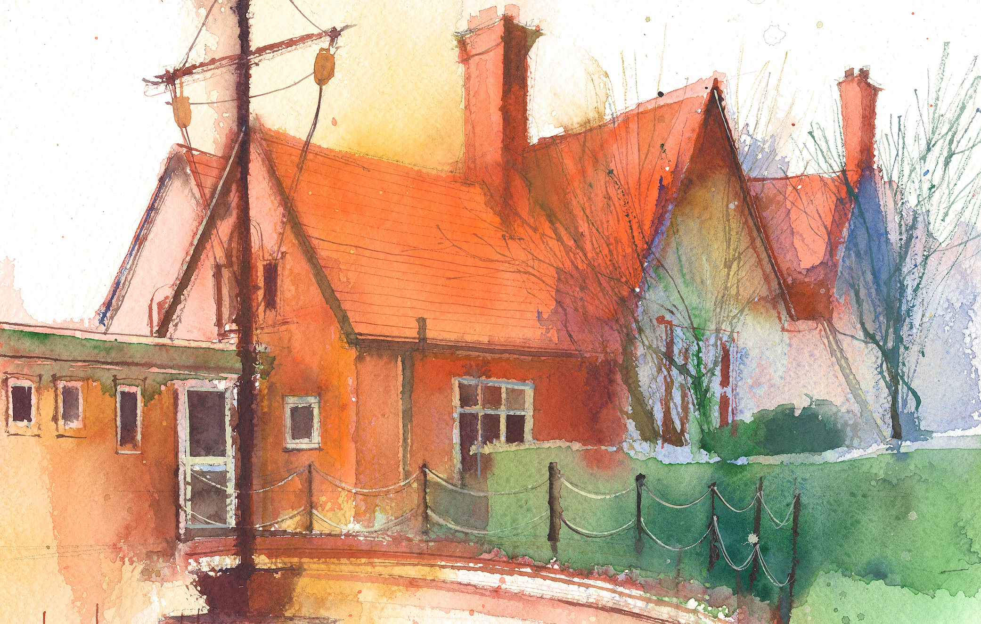
To contact your child’s class teacher, please email schooloffice@dawpool.wirral.sch.uk or phone 0151 648 3412

 | Lessons 09:00 – 10:30 |  |  | Lessons 10:45 – 12:15 |  | Lessons 13:15 – 15:30 | Additional Tasks
Monday | Phonics  Introduce /ur/ as ur  Blending practice |  |  | Maths  Number Bonds to 10  Tens Frame  To understand the composition of numbers and recognise numberbonds to 10. Using the tens frame. |  | Topic  During the afternoons we will undertake activities linked to all areas of the Early Years Curriculum;  Prime Areas; Communication and Language;  Personal, Social and Emotional Development;  Physical Development.  Specific Areas; Literacy, Maths, Understanding the World and Expressive Arts and Design.  Afternoon sessions will also include RE, HeartSmart and Forest Schools.  Summer 1 – Topic – Jungle – Tarzan  Activities will be linked to our class topic which is ‘Where in the World’. We aim to use children’s films as a hook for learning to help us find out more about the world around us. Throughout the year we will select films that enable us to cover all requirements of the Early Years Curriculum.  Will talk about where the film is set and find out where this country is on a map. We will then the theme of the film as a way of guiding our planning.  PLEASE NOTE  The very nature of the EYFS curriculum enables us to go with the interests of the children. The activities we plan are for a guide only.  Staff can use and adapt activities or add additional activities and not cover others. It is all dependent on how and where the children’s interests take us.  Activities are designed to cover several weeks, if needed.  A copy of the current topic plan is available to view on the class website page. | Useful Links / Other Recommended Activities  https://www.phonicsplay.co.uk/resources/phase/2 - phonics play – phase 2  https://www.bbc.co.uk/iplayer/episode/b08phr1g/numberblocks-series-2-ten numbeblocks 10
Tuesday | Phonics  /ur/ as ur  Segmenting practice |  |  | Maths  Number Bonds to 10  Tens Frame  To understand the composition of numbers and recognise numberbonds to 10. Using the tens frame.
Wednesday | Phonics  Introduce /ou/ as  ow  Blending practice |  |  | Maths  Number Bonds to 10  Tens Frame  To understand the composition of numbers and recognise numberbonds to 10. Using the tens frame.
Thursday | Phonics  /ou/ as ow  Segmenting practice |  |  | Maths  Number Bonds to 10  Tens Frame  To understand the composition of numbers and recognise numberbonds to 10. Using the tens frame.
Friday | Phonics  Tricky words  Common exception  word practice: come, do, so | P.E. |  | R.E.  Stories Jesus told |  | Forest School – seasonal changes

