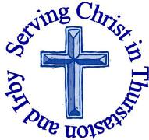
The Churches of
St Bartholomew and St Chad
Thurstaston and Irby
17th June – Trinity 3 – Father’s Day
Welcome to Church today.
We hope that you enjoy the service and gain a sense of God’s presence with us.

Children are Welcome at our Services
In St Chad’s, we have activity bags available and there is also a box of toys and cushions in the foyer, in case you feel your child would be happier playing there.
In St Bartholomew’s, there are some colouring sheets and toys at the back of church.
Children from age 2½ can attend Junior Church (term time) at St Chad’s
Collect  God our saviour,  look on this wounded world  in pity and in power;  hold us fast to your promises of peace  won for us by your Son,  our Saviour Jesus Christ.  Amen. |  |  | Post-Communion Prayer  O God, whose beauty is beyond our imagining and whose power we cannot comprehend:  show us your glory as far as we can grasp it, and shield us from knowing more than we can bear until we may look upon you without fear;  through Jesus Christ our Saviour.  Amen
FOR OUR PRAYERS THIS WEEK

For the World: Please pray for all those affected by Grenfell Tower fire as services are held to mark the 1st anniversary of the fire.
For the Parish: Give thanks for Fathers who are loving and kind and provide a good role model. Pray for children growing up without a Father figure. Pray for those who grieve because they have lost their father through bereavement recently.
For the sick: Please pray for Mark Dennison, Graham Barley, David Cunnington , Anna Drysdale,Christopher Todd and Eric Jones. Please pray for those in hospital.
For the Bereaved: Family and friends of Kay McDougal
From the Diocesan Prayer Cycle Pray for visitors to the Church marquee at the Cheshire Show, stewards, exhibitors and the Chaplain, not only during the show but in the days before as the marquee is prepared.
From the Anglican Prayer Cycle Archbishop Stephen Than Myint Oo, Archbishop of Myanmar and Bishop of Yangon
Services TODAY Trinity 3
8:00 am | Holy Communion | St. Bartholomew’s
9.30 am  11.15 am | Morning Worship  Holy Communion | St Chads  St Bartholomew’s

Services next week

Wednesday 20th June
10.15 am Holy Communion St Chads

Sunday 24th – Trinity 4

8.00 am Holy Communion St Bartholomew’s
9.30am Family Holy Communion St Chads
11.15am Holy Communion St Bartholomew’s

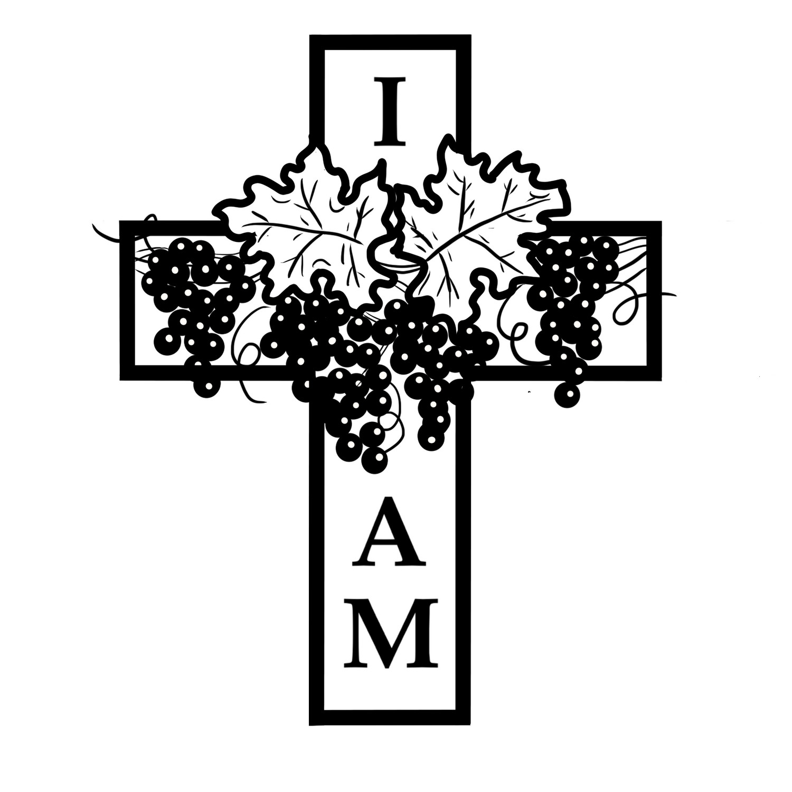
Notices and Announcements

EMU meeting 20th June 8pm at St Chads. The evening will consist of a talk about the RSPCA, all welcome.

Open PCC Meeting with Archdeacon Mike to look at Setting God’s People Free 7.30pm Monday 2nd July St Chads Extension – EVERYONE Welcome Setting God’s People Free is a national initiative by the Church of England to encourage whole-life discipleship, so that members of our congregations are better equipped to live out their Christian calling Monday to Saturday as well as Sunday. It is about helping people to live intentionally as Christians in the workplace, the home and the neighbourhood. Our parish has been chosen to take part in a Diocesan Pilot related to this initiative. The aim of the pilot will be to assess how well congregations feel they are currently equipped in this area, and how confident they feel about it, and to trial different approaches and resources with them. The learning from the pilot exercise will then feed into a major launch of Setting God’s People free in the diocese early in 2019. There are some copies of the summary report at the back of church or you can discover more here https://www.churchofengland.org/about/renewal-and-reform/more-about-renewal-reform/setting-gods-people-free

Men’s Breakfast 7th July 8.45am – 9.45am Eat, chat and share in fellowship at Aroma Café, Irby Village.
Diocesan Strategy for Mission: Important Discussion Meeting Thursday July 19th 7.30-9.00pm at St Michael’s Pensby. In recent months there has been some debate in the diocese about how the diocese is best able to meet the missional challenge that we now face. Bp Peter has written a discussion paper and would like to know what members of local churches think on the issues he raises (including Review of Deaneries, Diocesan Organisation, Ministry among younger people, Buildings and Human Resources). This is going to be done through deaneries. Our deanery meeting will be an open to anyone in the deanery who would like to express a view or be part of the discussion.
The Bishops paper can be found on the Diocesan website at http://www.chester.anglican.org/content/pages/documents/1527756028.pdf

Wirral Foodbank are short of Tins of Meat, Fish, Vegetables and Tomatoes, Instant Mash, Squash, UHT Milk, Coffee, Sponge Puddings, Washing Powder, Shampoo. They have plenty of Beans and Pasta. Donations can be dropped off at The Warrens Medical Centre; Tesco, Heswall; Sainsbury’s, Upton and Asda, Woodchurch

Thank you to all those contributed (time, energy and finance) to the lovely flower and vegetable border in the garden at St Chad’s.

Would you like to receive this notice sheet every week direct to your email in-box? If so, please send an email request to the parish office (office@thurstaston.org.uk)

GOSPEL READING: Mark 4:26-34

All: Glory to you, O Lord
²⁶ He also said, “The kingdom of God is as if someone would scatter seed on the ground, ²⁷ and would sleep and rise night and day, and the seed would sprout and grow, he does not know how. ²⁸ The earth produces of itself, first the stalk, then the head, then the full grain in the head. ²⁹ But when the grain is ripe, at once he goes in with his sickle, because the harvest has come.”
³⁰ He also said, “With what can we compare the kingdom of God, or what parable will we use for it? ³¹ It is like a mustard seed, which, when sown upon the ground, is the smallest of all the seeds on earth; ³² yet when it is sown it grows up and becomes the greatest of all shrubs, and puts forth large branches, so that the birds of the air can make nests in its shade.”
³³ With many such parables he spoke the word to them, as they were able to hear it; ³⁴ he did not speak to them except in parables, but he explained everything in private to his disciples.

All: Praise to you, O Christ
Readings for Today  1 Sam 15:34-16:13  2 Cor 5:6-10,14-17  Mark 4:26-34 | Readings for 24th June  1 Sam 17:57-18:5,10-16  2 Cor 6:1-13  Mark 4:35-41
Church Office: Mrs K Butler, St Chad’s Church, Roslin Road, Irby, CH61 3UH
Open Tuesday, Wednesday, Thursday, 9.30am-12.30pm (term time)
Tel 648 8169. Website: www.thurstaston.org.uk E-Mail: office@thurstaston.org.uk
Revd Jane Turner 648 1816 (Day off Tuesday). E-Mail: rector@thurstaston.org.uk

