**Tips to support Number skills**

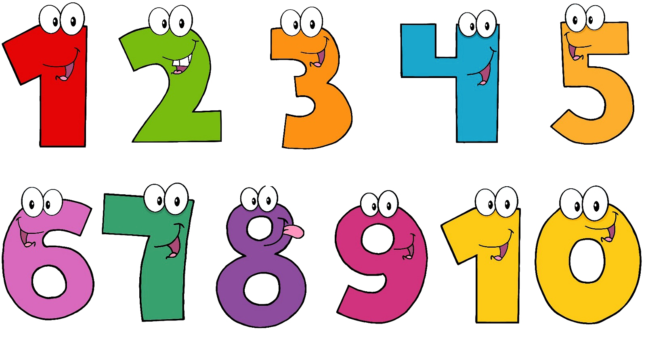

* Look for numbers in the local environment. Can they see any numbers? If they find some numbers they don't have to know the number name. If they do, that is great. However, at this stage It is just having an awareness of the difference between numbers and letters. You can then tell them the number name and suggest you look out for more numbers like that. Number hunting can be; house numbers, car number plates, on buses, prices in the supermarket.
* Play a version of I-Spy. "I spy a number 3, can you see a number 3?"
* Count with your child as much as possible. How many stairs to climb up/down, how many sweets in a packet, how many people sitting down for dinner, how many cars you can fit in a garage, how many lego blocks in a tower etc. We encourage the 'touch one, count one' strategy to ensure accurate counting e.g. counting the stairs as you go up and only saying a new number as you stand on a new step.
* Write numbers on a piece of paper and place them around the room/outdoor area. Say a number to your child and see if they can run and stand by the correct number.
* Encourage careful listening and counting. Get them to close their eyes whilst you clap a given number of times. Can they count how many times you clapped?
* Encourage children to match actions/objects to different numbers. If you say a number can they do that amount of claps, jumps, spins? Can they find that numbers of leaves, stones, toys? Can they use a drum or saucepan and spoon to bang that number of times?
* A tricky skill to master is using their fingers to show a certain number. If you say an number can they show that number of fingers? This requires quite a bit of finger dexterity and does take practice!
* The aim by the end of **Foundation 2** is that children will have a secure knowledge of numbers 0-20. It is vital that children have a full understanding of number recognition, matching objects to numbers, knowledge of a number line system and representing these numbers before moving onto bigger numbers higher up the school.