**Foundation 2 Weekly Timetable Week Commencing 31.03.25**

**To contact your child’s class teacher, please email** [**schooloffice@dawpool.wirral.sch.uk**](mailto:schooloffice@dawpool.wirral.sch.uk) **or phone 0151 648 3412**

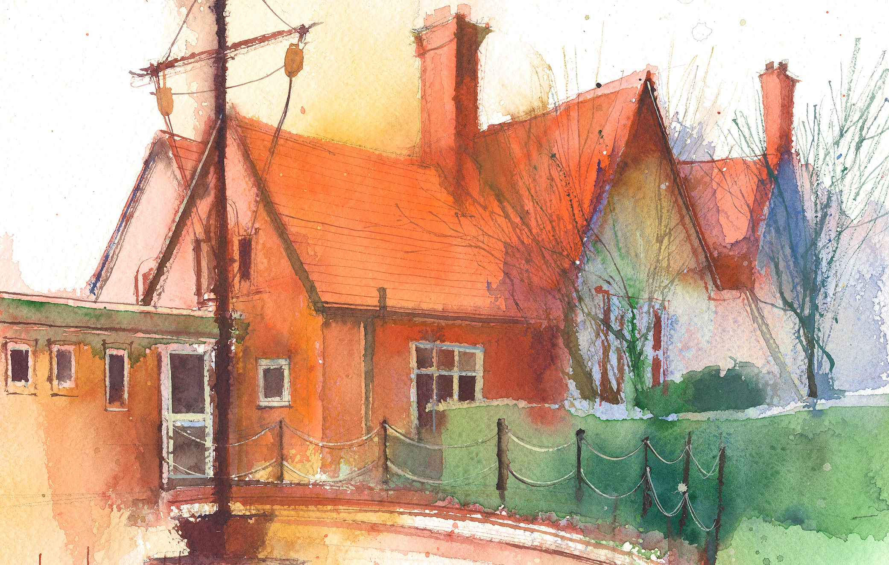

This timetable is available in the event that a Foundation 2 pupil is required to self-isolate at home, but the cohort remains open to other pupils.

Please visit the Foundation 2 **Remote Learning Page** on the school website to access any downloadable resources and activity sheets.

|  |  |  |  |  |  |
| --- | --- | --- | --- | --- | --- |
|  | **Session 1: 09:00-10:30** |  | **Session 2: ­­­­ 10:50 – 12:00** |  | **Session 3: 13:15 – 15:25** |
| **Monday** | **Phonics**  **By the end of this lesson your child should be able to:**  Consolidate ‘ch, sh, th’  (Week 24)  **We recommend the following resources and activities to achieve this objective:**  Blending practice.  Children will complete activities in their individual rocket phonics workbooks. | **Maths**  **By the end of this lesson your child should be able to:**  To say one more than a given number  **We recommend the following resources and activities to achieve this objective:**  On the carpet, create ten large car parking spaces using masking tape and provide ten toy cars.  Show the children how you park one truck in the car parking space. Ask them to whisper to their partner how many there would be if you added one more truck to the car park. Park one more truck in the car park and ask them to give a thumbs up or thumbs down if they were right. Encourage them to say, “One more than one is two”.  Repeat this until all the trucks are added to the carpark, using the language of ‘one more than’ to support understanding. | **Topic**  During the afternoons we will undertake activities linked to all areas of the Early Years Curriculum;  **Prime Areas**; Communication and Language;  Personal, Social and Emotional Development;  Physical Development.  **Specific Areas**; Literacy, Maths, Understanding the World and Expressive Arts and Design.  Afternoon sessions will also include RE, HeartSmart and Forest Schools.  Our current RE topic is ‘Special Times’. Planning for this can be found on the website.  Activities will be linked to our class topic which is ‘Where in the World’. We aim to use children’s books as a hook for learning to help us find out more about the world around us. Throughout the year we will select books that enable us to cover all requirements of the Early Years Curriculum.  We will talk about where the book is set and find out where this country is on a map. We will then use the theme of the book as a way of guiding our planning.  **PLEASE NOTE**  The very nature of the EYFS curriculum enables us to go with the interests of the children. The activities we plan are for a guide only.  Staff can use and adapt activities or add additional activities and not cover others. It is all dependent on how and where the children’s interests take us.  Activities are designed to cover several weeks, if needed.  A copy of the current topic plan is available to view on the class website page. |
| **Tuesday** | **Phonics**  **By the end of this lesson your child should be able to:**  Consolidate ‘ng, ai, ee’  **We recommend the following resources and activities to achieve this objective:**  Segmenting practice.  Children will complete activities in their individual rocket phonics workbooks. | **Maths**  **By the end of this lesson your child should be able to:**  To say one more than a given number.  **We recommend the following resources and activities to achieve this objective:**  Place the children into pairs and give each pair a pile of number cards (with numbers one to nine) and some interlocking cubes.  Explain that one of the pair must secretly turn over a number card and build a tower using the cubes of that number. The other child must count the bricks and make a new tower that has one more.  After they have done this, they can swap roles. |
| **Wednesday** | **Phonics**  **By the end of this lesson your child should be able to:**  Consolidate ‘igh, oa’  **We recommend the following resources and activities to achieve this objective:**  Blending practice  Children will complete activities in their individual rocket phonics workbooks. | **Maths**  **By the end of this lesson your child should be able to:**  To say one more than a given number  **We recommend the following resources and activities to achieve this objective:**  Place the children into pairs and provide them with number cards (from numbers one to nine). In the middle of the tray, place a pile of number shapes to ten.  Encourage the children to choose a number card. Then, they must hunt in the number shape pile for the number shape that is one more. |
| **Thursday** | **Phonics**  **By the end of this lesson your child should be able to:**  Consolidate ‘long oo and short oo’  **We recommend the following resources and activities to achieve this objective:**  Segmenting practice  Children will complete activities in their individual rocket phonics workbooks. | **Maths**  **By the end of this lesson your child should be able to:**  To say one more than a given number  **We recommend the following resources and activities to achieve this objective:**  Write numbers zero to nine in random order all over the board. Then, cover the numbers up using sticky notes so the children cannot see.  Provide the children with number fans and explain that they need to use their number fan to show the number one more than the one on the board.  Remove the sticky note covering the first number and if necessary, use the number line to show the children one more before encouraging them to find it for themselves. If the children are feeling confident, you can have a quick-fire round. |
| **Friday** | **PE**  **By the end of this lesson your child should be able to:**  *Move in a variety of different ways around the room including High and Low. To sequence a series of moves.*  **We recommend the following resources and activities to achieve this objective:**  During this half term the children will be learning ball skills. How to handle, control and pass balls carefully.  Skills will be taught using scarves, balloons, beachballs, footballs and smaller soft balls. | **Phonics**  **By the end of this lesson your child should be able to:**  *To learn to read the Common Exception words ‘’all’ ‘are’*  **We recommend the following resources and activities to achieve this objective:**  Children will complete activities in their individual rocket phonics workbooks. |