**Foundation 2 Weekly Timetable Week Commencing 28.04.25**

**To contact your child’s class teacher, please email** [**schooloffice@dawpool.wirral.sch.uk**](mailto:schooloffice@dawpool.wirral.sch.uk) **or phone 0151 648 3412**

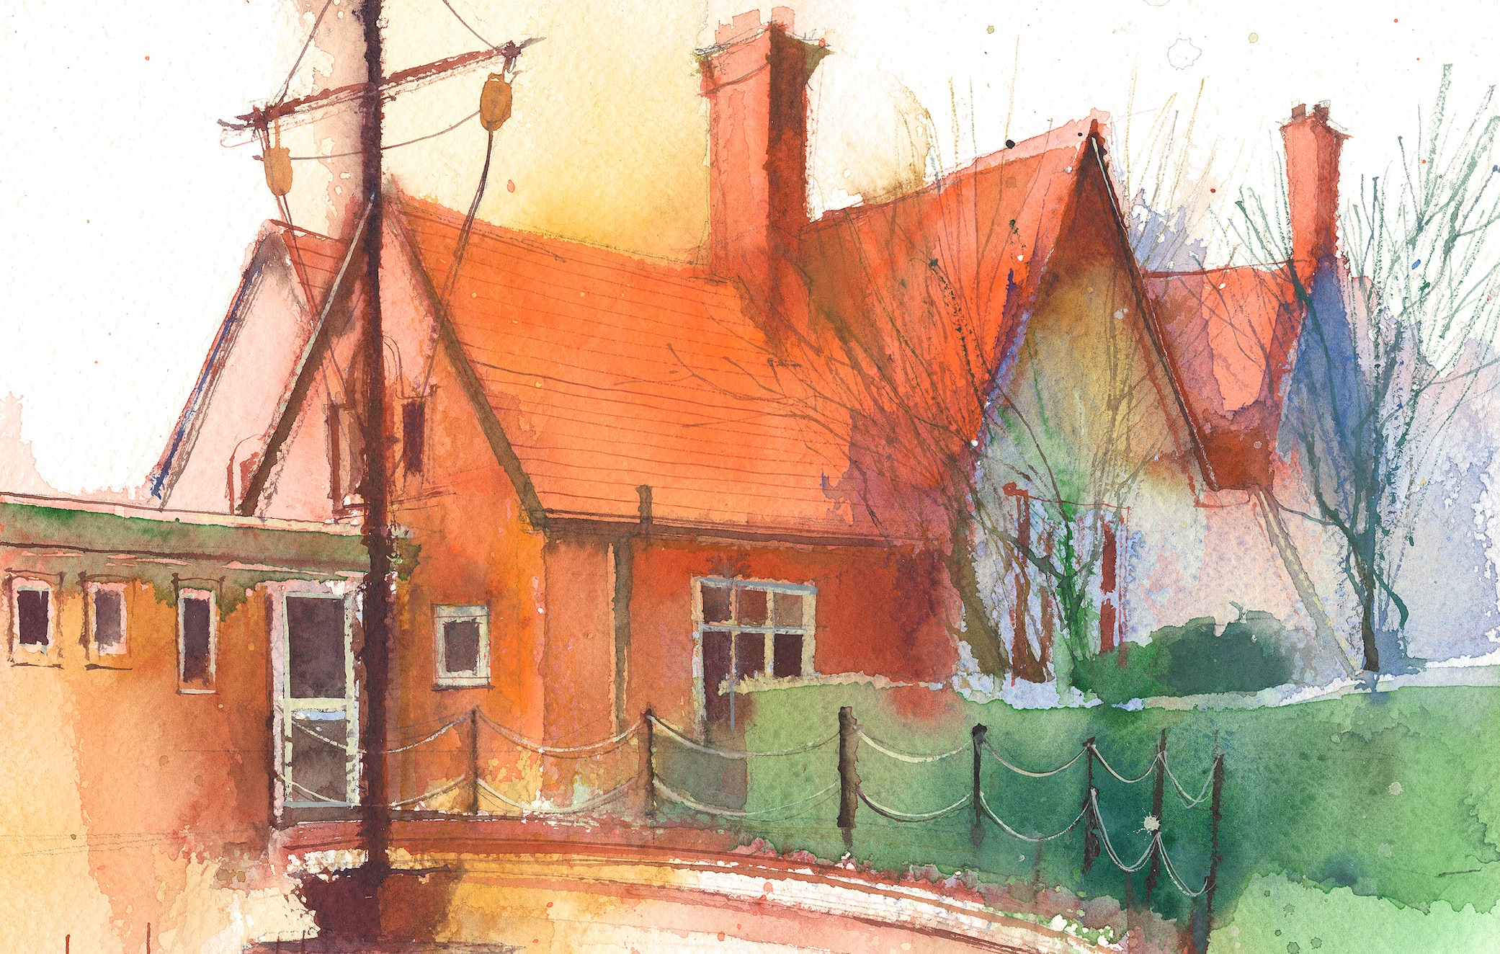

This timetable is available in the event that a Foundation 2 pupil is required to self-isolate at home, but the cohort remains open to other pupils.

Please visit the Foundation 2 **Remote Learning Page** on the school website to access any downloadable resources and activity sheets.

|  |  |  |  |  |  |
| --- | --- | --- | --- | --- | --- |
|  | **Session 1: 09:00-10:30** |  | **Session 2: ­­­­ 10:50 – 12:00** |  | **Session 3: 13:15 – 15:25** |
| **Monday** | **Phonics**  **By the end of this lesson your child should be able to:**  Recognise and say the digraph ‘ur’  (Week 26)  **We recommend the following resources and activities to achieve this objective:**  Blending practice.  Children will complete activities in their individual rocket phonics workbooks. | **Maths**  **By the end of this lesson your child should be able to:**  *To understand the composition of numbers and recognise numberbonds to 10. Using the tens frame.*  **We recommend the following resources and activities to achieve this objective:**  Place two picnic rugs, one labelled odd, one labelled even and two teddies on the carpet.  Collect plates of role-play food of odd and even numbers, for example six strawberries on one plate and five biscuits on another. Explain that the teddies want a picnic but there must be an even number of food and nothing left over.  Can the children help find out which food has an even amount?  Take the strawberries and allow the children to share them evenly between the teddies.  **How many strawberries are there on the plate? Can this amount be shared evenly?**  Discuss how this is an even amount as no strawberries are left over! Move this plate to the ‘even’ picnic rug. Repeat the activity with the biscuits. **How many biscuits are there? Can this amount be shared evenly? Why/why not? Is this even or odd? Why?** Discuss how there is one remaining, which means it is odd. Move this to the ‘odd’ picnic rug.  **Can you find the corresponding numicon shape for this plate? Is it an odd or even numicon shape?** | **Topic**  During the afternoons we will undertake activities linked to all areas of the Early Years Curriculum;  **Prime Areas**; Communication and Language;  Personal, Social and Emotional Development;  Physical Development.  **Specific Areas**; Literacy, Maths, Understanding the World and Expressive Arts and Design.  Afternoon sessions will also include RE, HeartSmart and Forest Schools.  Our current RE topic is ‘Special Times’. Planning for this can be found on the website.  Activities will be linked to our class topic which is ‘Where in the World’. We aim to use children’s books as a hook for learning to help us find out more about the world around us. Throughout the year we will select books that enable us to cover all requirements of the Early Years Curriculum.  We will talk about where the book is set and find out where this country is on a map. We will then use the theme of the book as a way of guiding our planning.  **PLEASE NOTE**  The very nature of the EYFS curriculum enables us to go with the interests of the children. The activities we plan are for a guide only.  Staff can use and adapt activities or add additional activities and not cover others. It is all dependent on how and where the children’s interests take us.  Activities are designed to cover several weeks, if needed.  A copy of the current topic plan is available to view on the class website page. |
| **Tuesday** | **Phonics**  **By the end of this lesson your child should be able to:**  Recognise and write the digraph ‘ur’  **We recommend the following resources and activities to achieve this objective:**  Segmenting practice.  Children will complete activities in their individual rocket phonics workbooks. | **Maths**  **By the end of this lesson your child should be able to:**  *To understand the composition of numbers and recognise numberbonds to 10. Using the tens frame.*  **We recommend the following resources and activities to achieve this objective:**  In the middle of the carpet, create a pile of Numicon shapes.  Pick up an even number shape (such as six) and an odd number shape (such as seven).  Guide the children to notice the shape of the seven, drawing their attention to the extra piece on the top. **What do you notice about this numicon shape?**  To enforce this, hold up another set of odd and even numbers and for discussion.  **Do you think this number shape is an odd or even number? Why?**  Place the shapes in a feely bag and get a child to select one from the bag .  Support them to feel the shape and discuss whether each shape is odd or even. **What does this shape feel like? What makes it feel odd/even?** |
| **Wednesday** | **Phonics**  **By the end of this lesson your child should be able to:**  Recognise and say the digraph ‘ou’  **We recommend the following resources and activities to achieve this objective:**  Blending practice  Children will complete activities in their individual rocket phonics workbooks. | **Maths**  **By the end of this lesson your child should be able to:**  *To understand the composition of numbers and recognise numberbonds to 10. Using the tens frame.*  **We recommend the following resources and activities to achieve this objective:**  Put the children into pairs and provide each pair with a mixed pile of numicon shapes.  Support the children to sort the numicon shapes into odd and even piles. **How do you know that this numicon shape is odd?**  Provide whiteboards and pens for the children to record which numbers are odd and which are even.  On a large sheet of paper, draw a line in the middle. Label one side ‘odd’ and the other ‘even’.  Collect the numbers that the children have recorded and write them under the corresponding label. You can also collect numicon shapes and stick them on the poster.  **Can you describe the shape to me? What do you notice about the odd/even shapes/numbers?** |
| **Thursday** | **Phonics**  **By the end of this lesson your child should be able to:**  Recognise and write the digraph ‘ou’  **We recommend the following resources and activities to achieve this objective:**  Segmenting practice  Children will complete activities in their individual rocket phonics workbooks. | **Maths**  **By the end of this lesson your child should be able to:**  *To understand the composition of numbers and recognise numberbonds to 10. Using the tens frame.*  **We recommend the following resources and activities to achieve this objective:**  Put the 100 square splat game on the board. Take the ‘odd and even number poster’ which was created during the ‘Numicon Shape Sort’ activity and place it next to the board.  Explain that we are going to use the poster to ‘splat’ the odd and even numbers on the 100 square.  Take the lowest number on the poster, 2, and with the children’s help find it on the 100 square.  If this number ends two, ‘splat’ it by circling it and saying ‘splat!’ Continue finding all the even numbers using the poster.  Pause during this activity **What do we notice about the even numbers? Can you predict which number is next?** Continue with numbers ending in 4, 6, 8, 10  **What do you notice about the odd numbers on the 100 square? Can you predict which numbers will be odd?** |
| **Friday** | **PE**  **By the end of this lesson your child should be able to:**  *Move in a variety of different ways around the room including High and Low. To sequence a series of moves.*  **We recommend the following resources and activities to achieve this objective:**  During this half term the children will be learning ball skills. How to handle, control and pass balls carefully.  Skills will be taught using scarves, balloons, beachballs, footballs and smaller soft balls. | **Phonics**  **By the end of this lesson your child should be able to:**  *To learn to read the Common Exception words ‘come’ ‘do’ ‘so’*  **We recommend the following resources and activities to achieve this objective:**  Children will complete activities in their individual rocket phonics workbooks. |