**Year 1 Weekly Timetable Week Commencing 5.5.25**

**To contact your child’s class teacher, please email** [**schooloffice@dawpool.wirral.sch.uk**](mailto:schooloffice@dawpool.wirral.sch.uk) **or phone 0151 648 3412**

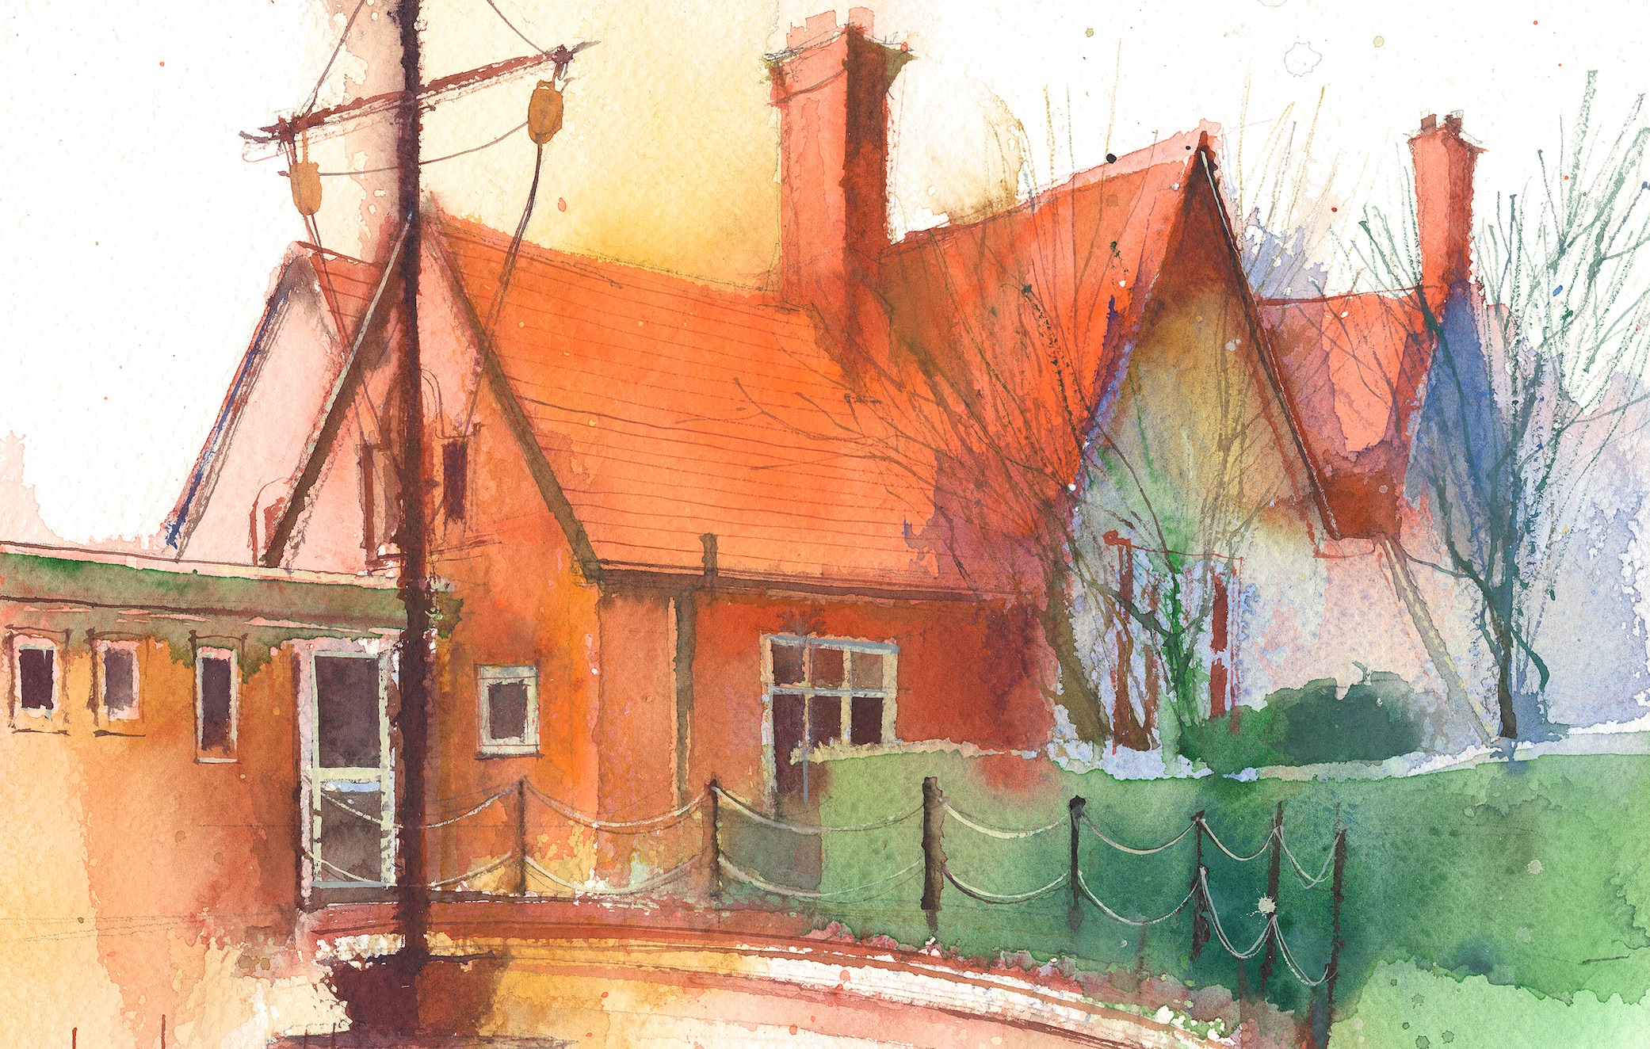

|  |  |  |  |  |  |  |
| --- | --- | --- | --- | --- | --- | --- |
|  | **Lessons 09:00 – 10:30** |  | **Lessons­­­­ 10:45 – 12:15** |  | **Lessons 13:15 – 15:30 (Incorporating 15-minute break)** | **Additional Tasks** |
| **Monday** |  | **Bank holiday Monday** |  | Useful Links / Other Recommended Activities  **Oak National Academy**  <https://classroom.thenational.academy/>  **BBC Bitesize**  <https://www.bbc.co.uk/bitesize>  **Purple Mash**  <https://www.purplemash.com/sch/dawpool#/>  **Recommended Reading List**  [See here](https://www.dawpool.wirral.sch.uk/website/recommended_reading_lists/577821) |
| **Tuesday** | **Phonics:** consolidate phase 3sounds.  **English:** Role on the Wall and Response to Image – A Fisherwoman or Fisherman | **Maths:** To know how to make arrays.  **ERIC / GR** | **Fluent in 5**  **Science:**To know which part of the body is associated with each sense.  To be able to observe closely, using simple equipment  **No Outsiders:** Errol’s Garden |
| **Wednesday** | **Phonics:** consolidate phase 3 sounds.  **English:** Developing Enquiry – Gaining wider background knowledge into fishing  communities | **Maths:** To know how to make doubles.  **ERIC / GR** | **Fluent in 5**  **TRIP TO ST BART’S**  **RE:** I know what happens at a child’s baptism.  (inc. seeing the font, baptism certificate and candle, the baptism record, hearing what the Godparents and parents say at the service.) |
| **Thursday** | **Phonics:** consolidate phase 3 sounds.  **Spag** | **Maths:** To know how to read and complete number lines to 20.  **ERIC / GR** | **Fluent in 5**  **Heartsmart:** Fake is a mistake.  **PE:** The focus of the learning is to understand the basic principles of defence.  **Picture News** |
| **Friday** |  | **See Mrs Clark’s Planning** |  |