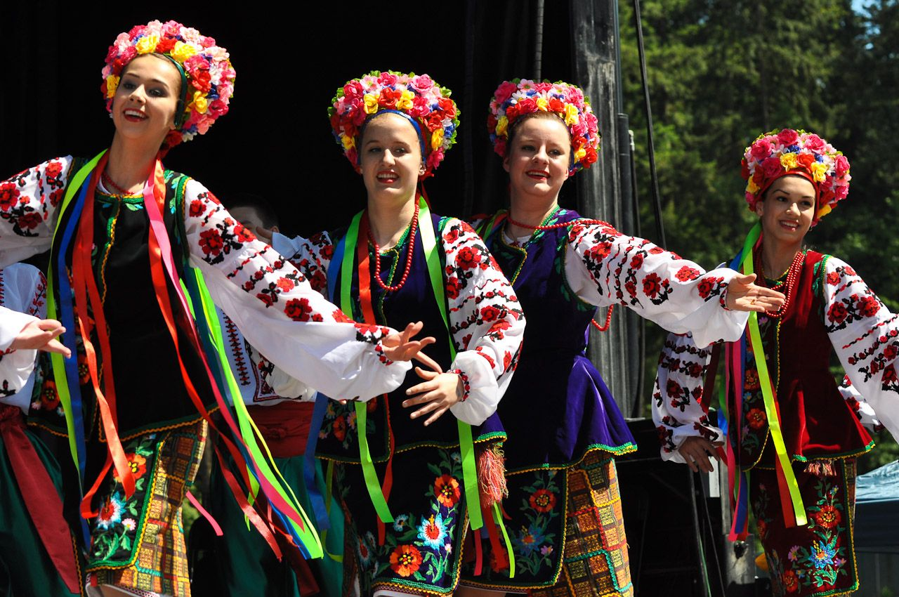

Tuesday 27th May

Warm Hub Guests

**Ukrainian dancers**

***We are thrilled to welcome dancers from Ukraine.***

***They will be dancing in national costumes to traditional Ukrainian music.***

***The event, including refreshments, is entirely free,***

***but donations for the dancers themselves will be welcome.***

**The Warm Hub at St. Chad’s Church, Irby is open from 9.30 a.m.,**

**with tea, coffee and biscuits available.**

**The Ukrainian Dancers’ performance will start at 11.00 a.m.**

**Everyone is welcome for what promises to be a really lovely and entertaining session.**

***We are thrilled to welcome dancers from Ukranian. They will be dancing in national costumes to traditional Ukranian music.***

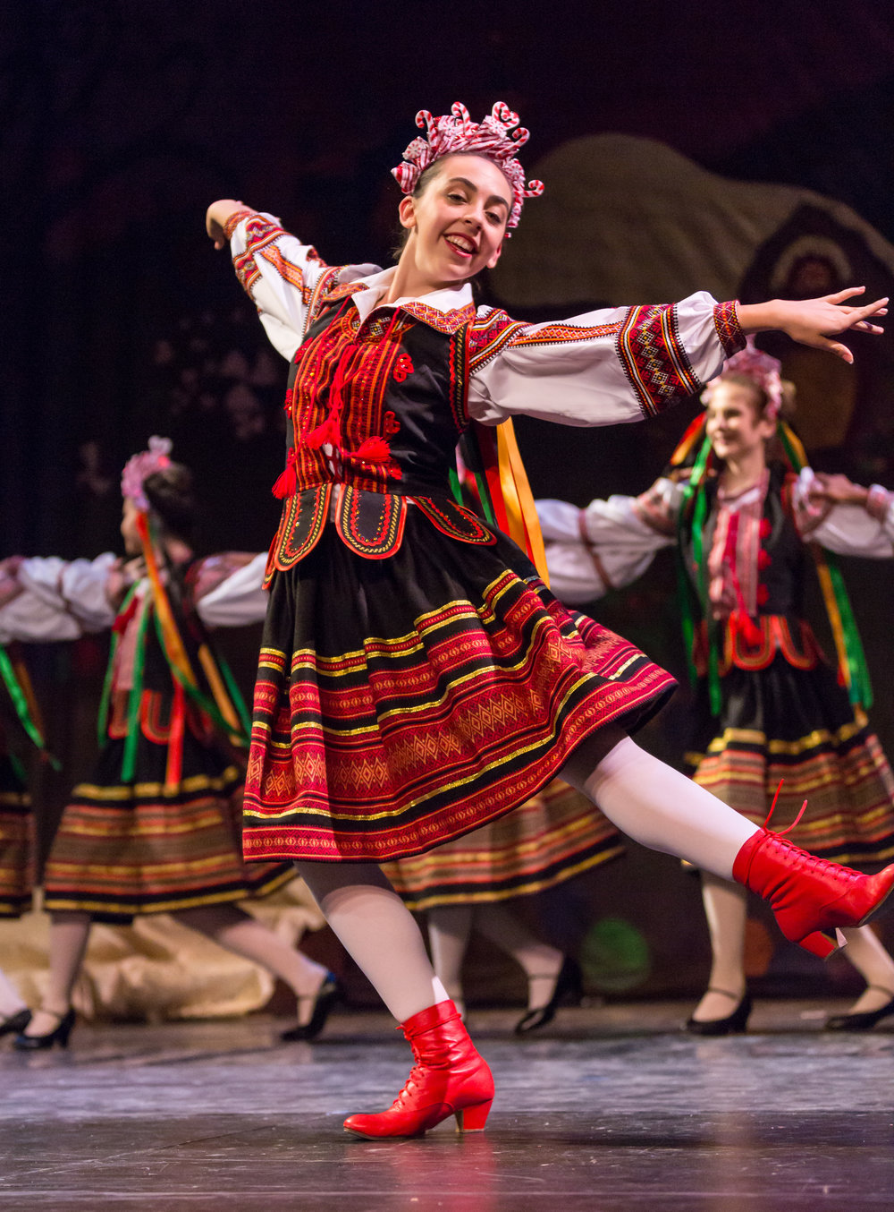

***Whilst the event, including refreshments, is entirely free***

**The Warm Hub at St. Chad’s Church, Irby opens at 9.30 a.m.**

**The Ukranian Dancers’ performance, which is free, will start at 11.00 a.m. Do join us earlier than that for refreshments.**

**Everyone is welcome for what promises to be an interesting and entertaining session.**