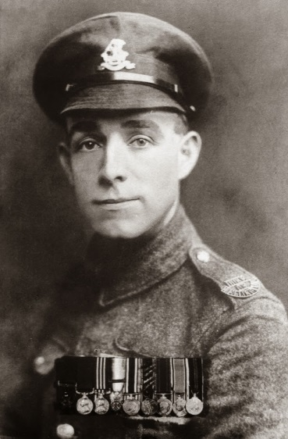
Henry Tandey became the most decorated private soldier in World War One. His bravery though, would be eclipsed in the run up to World War Two by allegations he had spared Adolf Hitler's life, in 1918. But, is the story accurate?
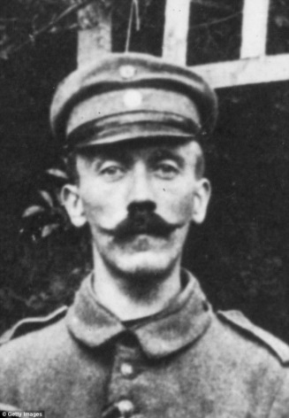
The two events were separated by 20 years. On 28 September 1918, Pte Tandey earned the Victoria Cross "for most conspicuous bravery and initiative" at the fifth Battle of Ypres.
Twenty years later, Hitler himself is said to have planted the seeds of the legend during a visit to the Fuhrer by British Prime Minister Neville Chamberlain, in his doomed attempt to secure "peace for our time".
He apparently seized on the fact that along with many of his fellow soldiers, Pte Tandey had tempered justice with mercy, refusing to kill unarmed, injured men in cold blood. The leader of the Third Reich claimed he was one of those spared.
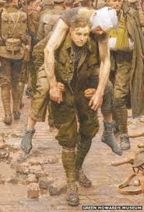
At his Bavarian retreat the Berghof, Chamberlain noticed a picture on the wall of Hitler's study, depicting a scene from a battle at Menin crossroads in 1914. The soldier in the foreground was apparently Pte Tandey, carrying a fellow soldier to safety.
Hitler told Chamberlain the soldier had pointed a gun at him but spared him.
"That man came so near to killing me that I thought I should never see Germany again," Hitler is alleged to have said.
"Providence saved me from such devilish accurate fire as those English boys were aiming at us."
The museum of the Green Howards - Pte Tandey's regiment, which commissioned the painting in 1923 from Italian war artist Fortunino Matania - confirmed a copy was hanging at Hitler's retreat.
Story Plan:
Paragraph 1
Description of no-mans-land. Focus on mist, shadows, light/dawn, early morning. Henry is cold.
Paragraph 2
Henry thinks he sees a figure in the mist that lurches into vision and then disappears again. Focus on ghost, uncertainty
Paragraph 3
The figure lurches back into view and the two men make eye contact. Henry aims but doesn’t fire. The figure stumbles away. Focus on increased heart rate, adrenalin then compassion.
Paragraph 4
Postcard from the front. Telling of his encounter and how glad he is he didn’t kill a man who was no threat.
Paragraph 5
Change of Voice
Web Page Screen shot from www.worldwaronestories.com giving a brief account of the story from Hitler’s perspective. Include direct speech, first person, clear precise language. Interview with Henry Tandey in old age saying he wishes now he had taken the shot.

