**Weekly Timetable Year Group WC 6th May 2025**

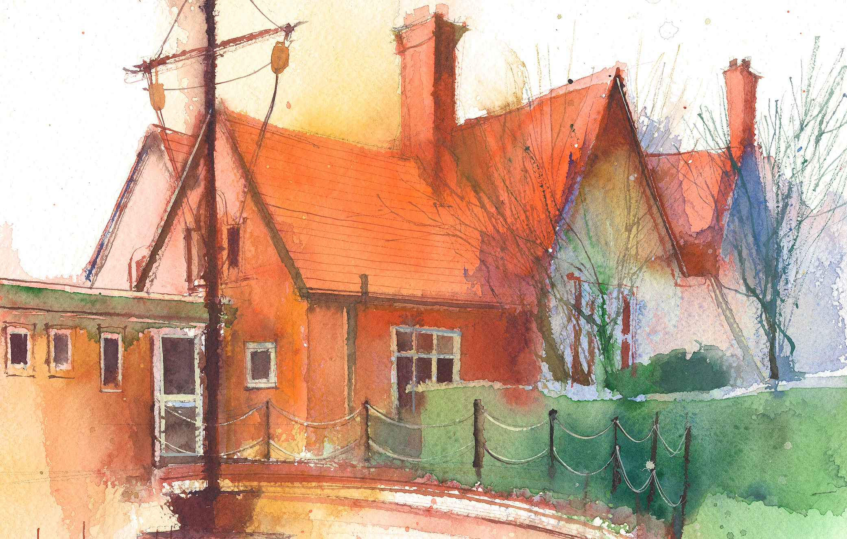

|  |  |  |  |  |  |  |
| --- | --- | --- | --- | --- | --- | --- |
|  | **Lessons 09:00 – 10:30** |  | **Lessons­­­­ 10:45 – 12:15** |  | **Lessons 13:15 – 15:30 (Incorporating 15-minute break)** | |
| **Monday** | BANK HOLIDAY | BANK HOLIDAY | BANK HOLIDAY | BANK HOLIDAY |
| **Tuesday** | Maths  Position and Direction Lesson 5  To know how to identify lines of symmetry in 2-D shapes  Lesson 5 slides and worksheets associated with slides | Literacy (POR)  To create a short poem based on the sight and sounds of the Amazon Rainforest.  Based on lessons 6 and 7 POR lesson ideas | Science (Forces)  Children will write a report from last weeks science experiment publish their results and explain scientific reasons for their findings. | |
| **Wednesday** | Mrs Hall | Mrs Hall | Mrs Hall | |
| **Thursday** | Maths  Position and Direction Lesson 6  To know how to reflect using a mirror line  Lesson 6 slides and worksheets associated with slides | Literacy (POR)  Based on session 8 lesson outline from POR scheme based on chapter 3 of the book.  Children to individually write a short diary entry for Maia, written the evening after Miss Minton has revealed her plan. | Topic work (South America)  Children to research and record information about one country in South America. Use Google docs to create their own information booklet. | |
| **Friday** | Questful R.E.  Explore the role of women in the Old Testament.  Jochebed (Moses’ mother) and the Egyptian Princess  Unit 5.5 Old Testament women | Computing (Year 4)  Animations  To find out how 2Animate animations can be created in a similar way using technology.  Purple Mash Lesson 1 | **Mrs Wood**  **PPA Cover** | |

**Weekly**

Worship (Mon & Fri) 10:10-10:30

HeartSmart (20-minutes per week)

Picture News (20-minutes per week)

No Outsiders (20-minutes per week)

My Happy Mind (20-minutes per week)

Reading for Pleasure (at least 10-minutes per day)

**Weekly**

Maths (daily)

Rapid Reasoning / Fluent in Five (daily)

Power of Reading x 3

Punctuation & Grammar x1

Spelling x1

Reading Comprehension x1

RE

Science

PE

**Weekly / Fortnightly / Blocked**

History

Geography

DT

Art

Music

Computing (MFL) KS2

(Y3/4 September – Feb)

(Y5/6) February – July)