Year 1 Weekly Timetable Week Commencing 22.4.24
To contact your child’s class teacher, please email schooloffice@dawpool.wirral.sch.uk or phone 0151 648 3412
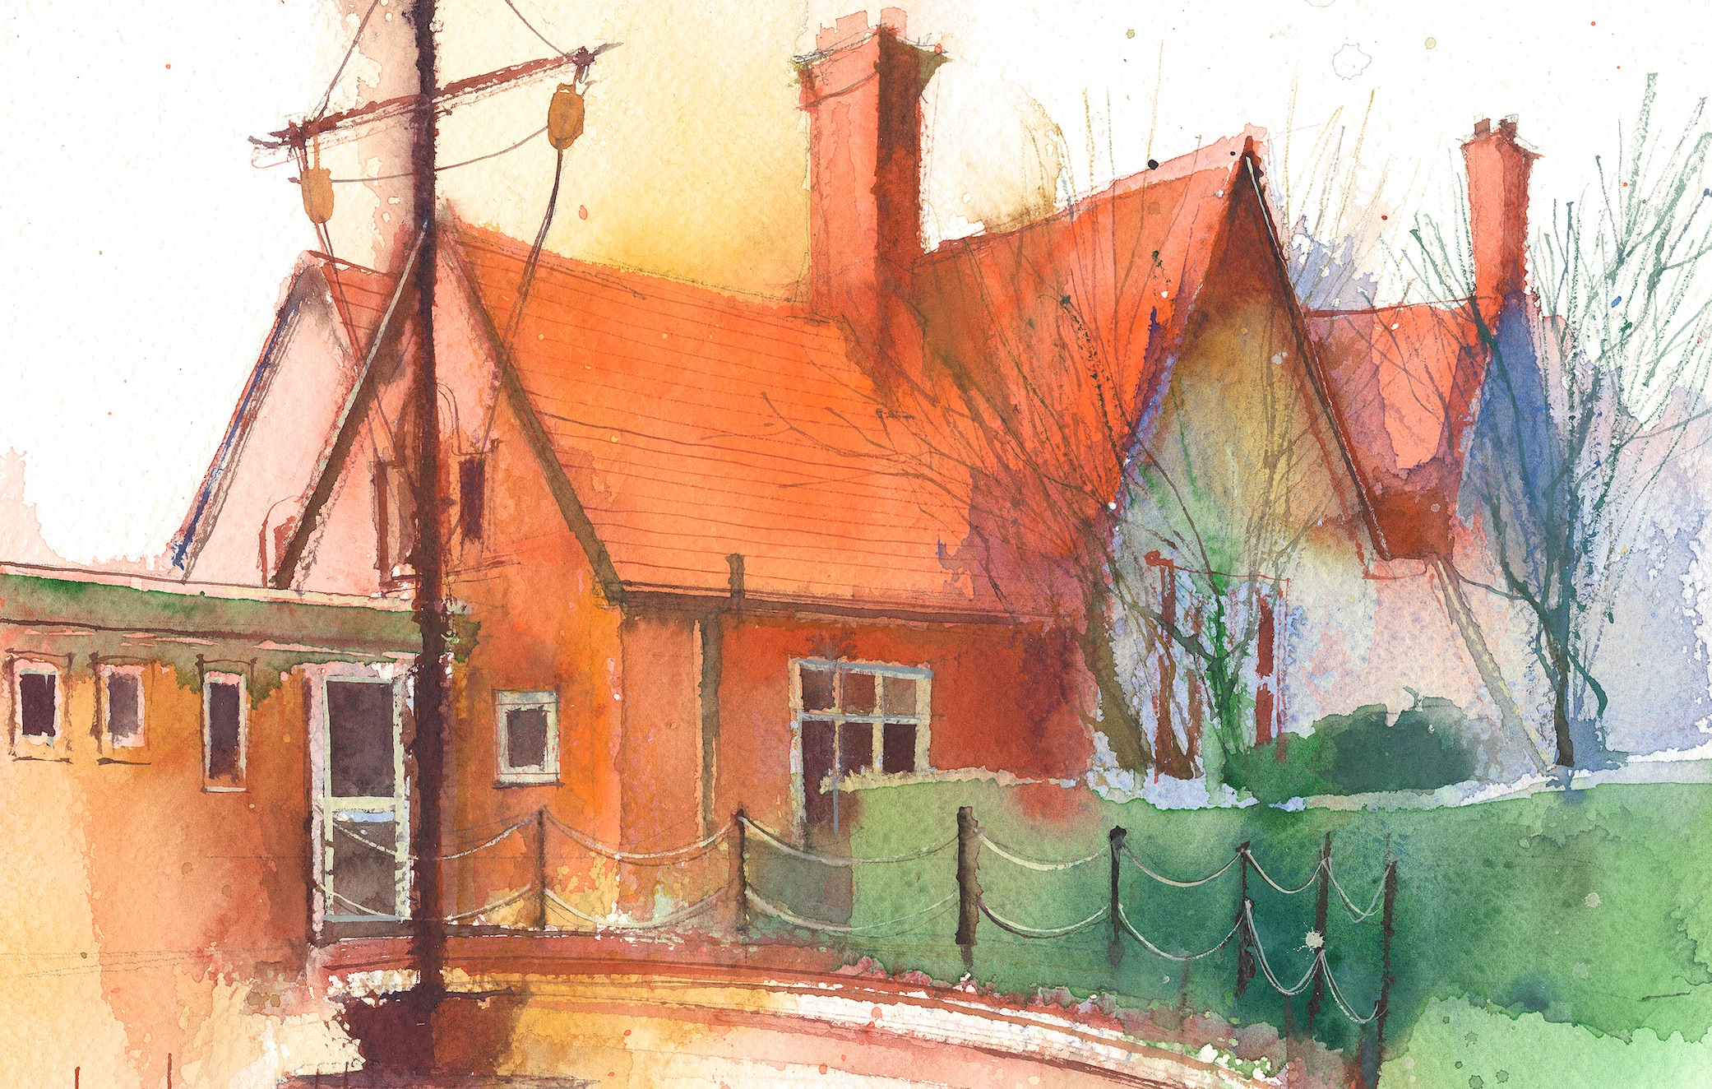

 | Lessons 09:00 – 10:30 |  | Lessons 10:45 – 12:15 |  | Lessons 13:15 – 15:30 (Incorporating 15-minute break) | Additional Tasks
Monday | Phonics: ul as le (blending practice)  English: Alien words practise. |  | Maths: to share and group objects into 2 equal groups. |  | FOREST & RE: Unit 1.8: Joseph, learning how to tie knots and making baskets out of sticks to store the grain in the story of Joseph.  My Happy Mind: How to have good relationships with people.  Guided Reading/CP | Useful Links / Other Recommended Activities  Oak National Academy  https://classroom.thenational.academy/  BBC Bitesize  https://www.bbc.co.uk/bitesize  Purple Mash  https://www.purplemash.com/sch/dawpool#/  Recommended Reading List  See here
Tuesday | Phonics: ul as le (segmenting practice)  English: responding to music through work songs and Sea Shanties |  | Maths: To split an object (shape) into two equal parts; to identify shapes that have been split into two equal parts. |  | Science: Identify and name a variety of common animals including fish, amphibians, reptiles, birds and mammals.  Heartsmart: Fake is a mistake.  Guided Reading/CP
Wednesday | Phonics: t and d as ed (blending practice)  English: Developing a sense of people and place - Storytelling and Creative Writing. |  | Maths: To share and group objects into 4 equal groups. |  | PE:. Jumping – different speeds, directions and levels.  Picture News  Guided Reading/CP
Thursday | Phonics: t and d as ed (segmenting practice)  English: Shrine Boxes, Personal Stories and Family Histories Project |  | Maths: To split an object (shape) into four equal parts; to identify shapes that have been split into four equal parts |  | Topic (The Seaside)  Geography: I can know and label the key features of the seaside.  No Outsiders  Guided Reading/CP
Friday | Phonics: Common exception word practice: oh, their  English: Alien words practise. |  | Maths: To share and group objects into halves and quarters; to determine half of a number and a quarter of a number. |  | Music: “Your imagination” Listen and Appraise.  Golden Time: Some special toys are brought in to play with!

