Foundation 1 -phase 1 phonics
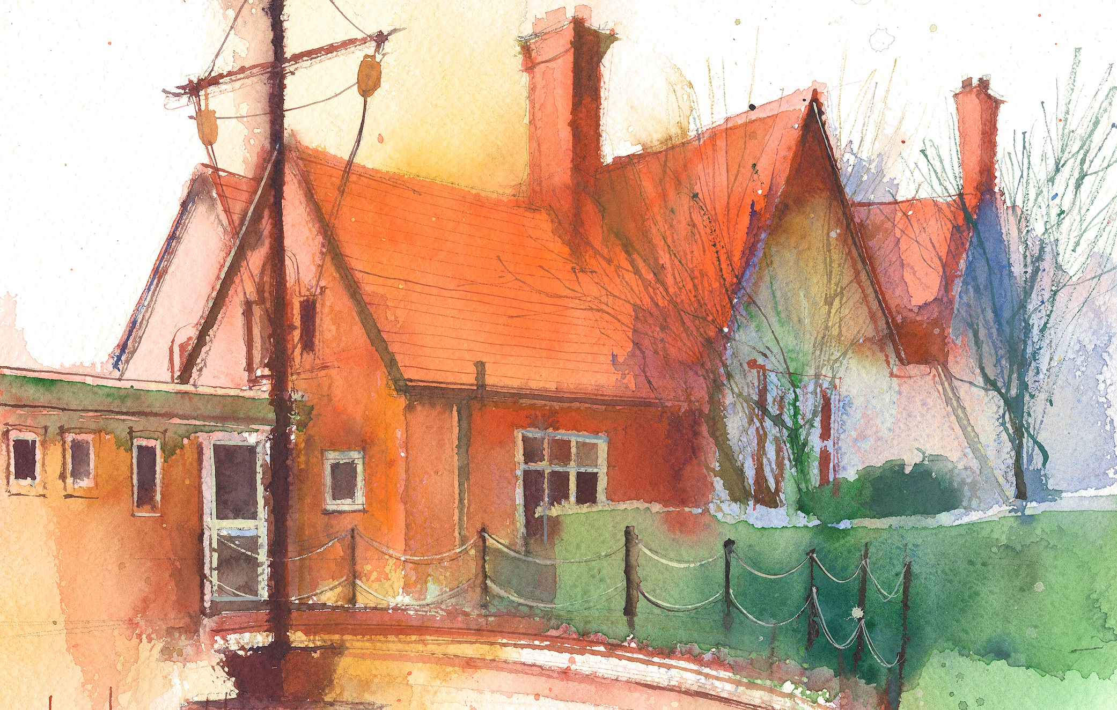

Phase 1: Aspect 5: Alliteration
Main Purpose: To develop understanding of alliteration. To listen to sounds at the beginning of words and hear the differences between them. To explore how different sounds are articulated, and to extend understanding of alliteration
Revisit/ Review | Introduce sitting skills and explain that we are going to do some investigation in to sounds. What sense/part of our body do we need to use?  Learning cards – good sitting, good looking, good listening, brain boxes on. | Revise sitting and listening skills.  Learning cards – good sitting, good looking, good listening, brain boxes on. | Revise sitting and listening skills.  Learning cards – good sitting, good looking, good listening, brain boxes on. | Revise sitting and listening skills.  Learning cards – good sitting, good looking, good listening, brain boxes on. | Revise sitting and listening skills.  Learning cards – good sitting, good looking, good listening, brain boxes on.
Teach | I spy names  Sit in a circle and play ‘I spy names’. “I spy someone’s name beginning with ‘s’. Who can it be”  The child with the name beginning with ‘s’ stands up and all the children say their name. | Digging for Treasure  Collect two sets of objects. Demonstrate finding them. Say the initial sound. Match more objects to the sounds and recite them. “Wow! You’ve found a car. Now we have a cow, a candle and a car”. | Tony the Train’s busy day.  Take the train along the carpet saying a story about Tony’s busy day. Say train sounds (clickety clack) and then s-t-o-p. Something is in the way. Say what is in the way (big brown bear) and then Tony returns to the other trains. | Sound bag  Place objects with the same initial sound in a bag and pull them out one at a time, saying the initial sound. | Mirror Play  Show the children how to hold a mirror sensibly and explain that we are going to look at our mouths when we make sounds.
Practise | Take it in turns to say the next person’s name sound and repeat. | Repeat activity and let children take it in turn to find objects and say the initial sound. | Repeat the activity and add one extra object each time. Saying the list of objects. | Children practise saying the initial sound, sssssssss for snake etc. after the adult has removed an object. | Children practise making mouth shapes whilst looking at the mirror.

