**Year 5 Weekly Timetable Week Commencing 19.05.25**

**To contact your child’s class teacher, please email** [**schooloffice@dawpool.wirral.sch.uk**](mailto:schooloffice@dawpool.wirral.sch.uk) **or phone 0151 648 3412**

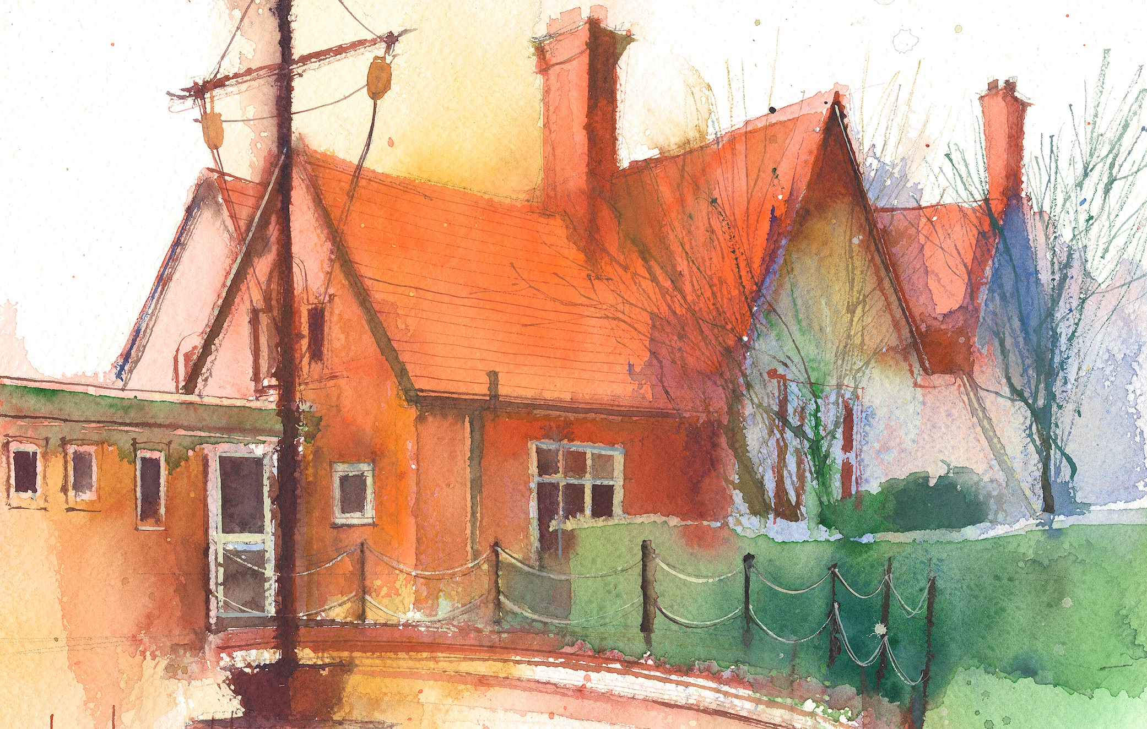

|  |  |  |  |  |  |  |
| --- | --- | --- | --- | --- | --- | --- |
|  | **Lessons 09:00 – 10:30** |  | **Lessons­­­­ 10:45 – 12:15** |  | **Lessons 13:15 – 15:30 (Incorporating 15-minute break)** | **Additional Tasks** |
| **Monday** |  |  |  | Useful Links / Other Recommended Activities  **Oak National Academy**  <https://classroom.thenational.academy/>  **BBC Bitesize**  <https://www.bbc.co.uk/bitesize>  **Purple Mash**  <https://www.purplemash.com/sch/dawpool#/>  **Recommended Reading List**  [See here](https://www.dawpool.wirral.sch.uk/website/recommended_reading_lists/577821) |
| **Tuesday** |  |  |  |
| **Wednesday** | **Year 5 Grammar**  By the end of this lesson your child should be able to:  **Spring 2Spag Assessment** | **Year 5 Maths**  By the end of this lesson your child should be able to:  **Know how to solve balancing**  **calculations.** | **Year 5 Art – Express Yourself**  By the end of this lesson your child should be able to:  **To explore how lines and fonts can express ideas.**  **Year 5 Music – Liverpool Philharmonic – The World in One City: A Musical Journey**  **Lesson 8 – Homeward Bound!**  By the end of this lesson your child should be able to:  **· use and understand staff and other musical notations.**  **· appreciate and understand a wide range of high-quality live and recorded music drawn from different traditions and from great composers and musicians.** |
| **Thursday** |  |  |  |
| **Friday** | **Year 5 Reading Comprehension –Non-Fiction-At last the jousts begin! From Castle Diary by Richard Platt and Chris Riddell**  By the end of this lesson your child should be able to: **Understand and respond to the text accurately.** |  |  |