Mrs Hall Weekly Timetable Y4 Week Commencing 22.04.24
To contact your child’s class teacher, please email schooloffice@dawpool.wirral.sch.uk or phone 0151 648 3412
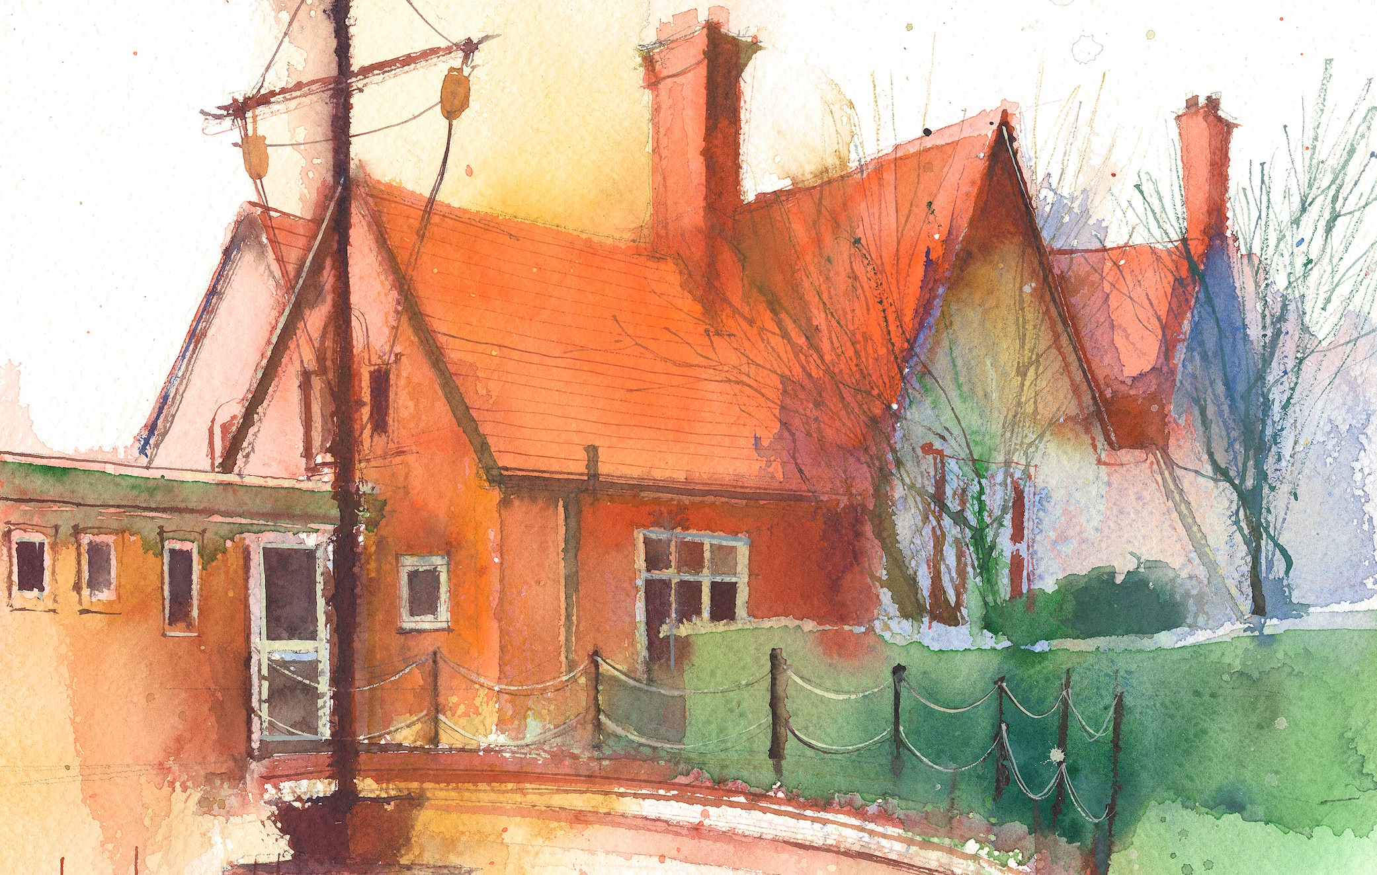

 | Lessons 09:00 – 10:30 |  | Lessons 10:45 – 12:15 |  | Lessons 13:15 – 15:30 (Incorporating 15-minute break) | Additional Tasks
Monday |  |  |  |  |  | Useful Links / Other Recommended Activities  Oak National Academy  https://classroom.thenational.academy/  BBC Bitesize  https://www.bbc.co.uk/bitesize  Purple Mash  https://www.purplemash.com/sch/dawpool#/  Recommended Reading List  See here
Tuesday

Wednesday

Thursday | Year 4 Grammar  By the end of this lesson your child should be able to:  Understand that contractions which end in n’t and the words no, nothing, never and nowhere are negative words. By using negative words, we can change the meaning of a sentence. |  | Year 4 Maths  By the end of this lesson your child should be able to:  Know how to compare amounts of money. |  | Year 4 Science  By the end of this lesson your child should be able to:  To be able to recognise  that sounds get fainter as  the distance from the  sound increases.  To be able to use  scientific enquiry to  answer a question.  To be able to set up a  simple practical enquiry.
Friday | Year 4 Maths  By the end of this lesson your child should be able to:  Know how to estimate using money. |  | Year 4 Reading Comprehension – Robots in Films and TV Programmes  By the end of this lesson your child should be able to:  To look and listen to a non-fiction text about robots in films and TV programmes. Respond to and answer questions about the text. |  | Year 4 RE  By the end of this lesson your child should be able to:  Listen to the account of the transfiguration (Matthew 17:1-8, Mark 9:2-8, Luke 9:28-36) then watch a short film clip.  Once again a voice comes from heaven. Whose voice is it?  How do the events of this story reveal Jesus to be the Son of God?  Ask the children to imagine being one of the Disciples who witnessed the Transfiguration. What would they have written in a diary that evening.

