Year 1 Weekly Timetable Week Commencing 29.4.24
To contact your child’s class teacher, please email schooloffice@dawpool.wirral.sch.uk or phone 0151 648 3412
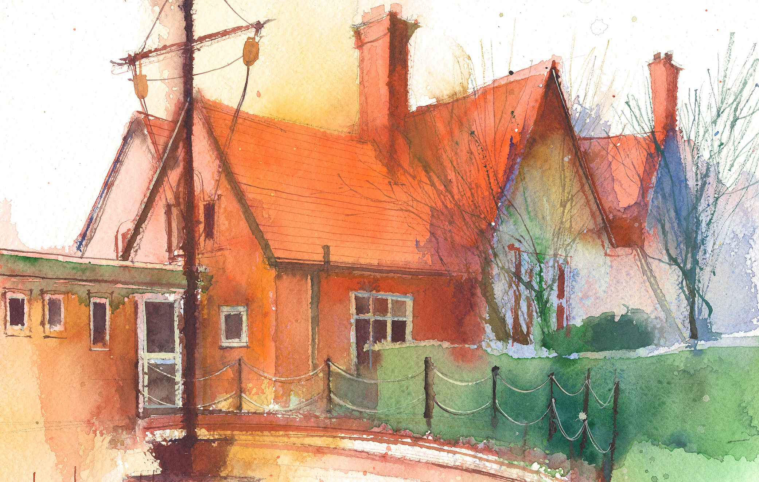

 | Lessons 09:00 – 10:30 |  | Lessons 10:45 – 12:15 |  | Lessons 13:15 – 15:30 (Incorporating 15-minute break) | Additional Tasks
Monday | Phonics: m as mb (blending practice)  English: Alien words practise. |  | Maths: To count in sequences of 10 followed by counting ones; to increase confidence with number lines and Base 10 materials in order to count numbers to 100. |  | FOREST & RE: Unit 1.8: Joseph, learning how to tie knots and making baskets out of sticks to store the grain in the story of Joseph.  My Happy Mind: How to have good relationships with people.  Guided Reading/CP | Useful Links / Other Recommended Activities  Oak National Academy  https://classroom.thenational.academy/  BBC Bitesize  https://www.bbc.co.uk/bitesize  Purple Mash  https://www.purplemash.com/sch/dawpool#/  Recommended Reading List  See here
Tuesday | Phonics: m as mb (segmenting practice)  English: Shrine Boxes, Personal Stories and Family Histories Project |  | Maths: To understand the value of the tens and ones digits in a number; to use multiple methods of representing and constructing a number. |  | Science: Identify and name a variety of common animals that are carnivores, herbivores and omnivores. Identifying and classifying. To identify, name and sort animals that are herbivores, carnivores and omnivores.  Heartsmart: Fake is a mistake.  Guided Reading/CP
Wednesday | Phonics: n as kn (blending practice)  English: I can draw and label about what is important to my family. |  | Maths: To review and extend skills and strategies related to number comparison; to place numbers in order from smallest to greatest and vice versa. |  | PE:. Jumping – different speeds, directions and levels. Some sports day practise.  Picture News  Guided Reading/CP
Thursday | Phonics: n as kn (segmenting practice)  English: I can write about what is important to my family. |  | Maths: To see patterns of numbers when increasing or decreasing by 1, 2 or 5; to use a number line, a 100-chart and Base 10 materials to represent numbers |  | Topic (The Seaside)  Geography: I know about castles and why they are designed that way.  No Outsiders  Guided Reading/CP
Friday | Phonics: Common exception word practice: people  English: Alien words practise. |  | Maths: To practise various concepts covered in the chapter. |  | Music: “Your imagination” Listen and Appraise.  Golden Time: Some special toys are brought in to play with!

