Foundation 1 -phase 1 phonics
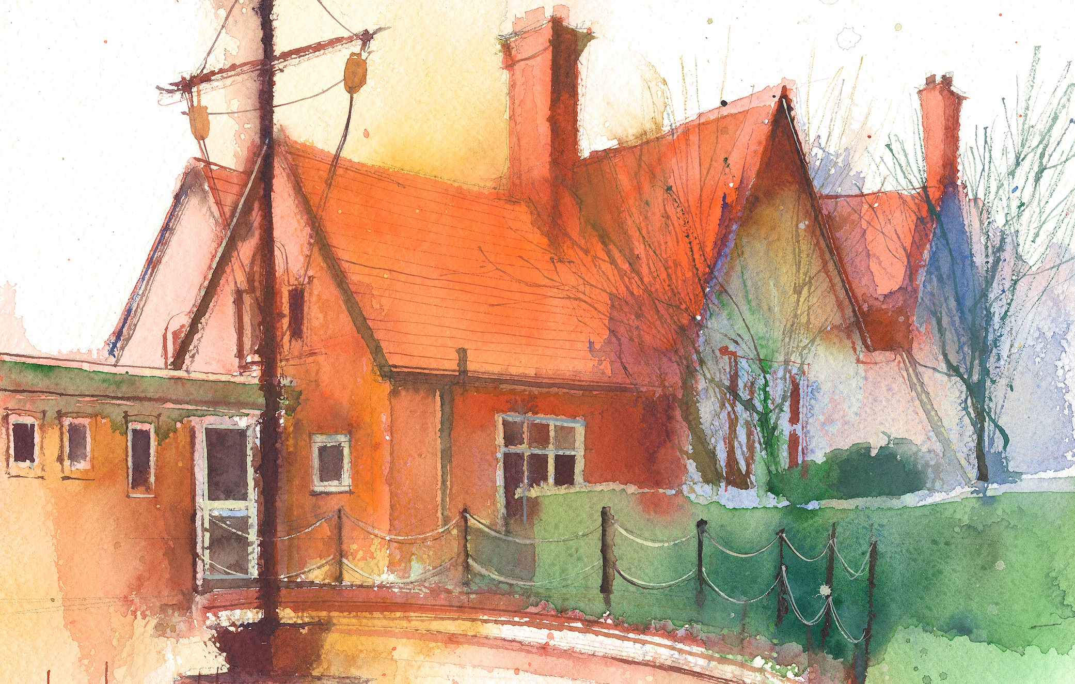

Phase 1: Aspect 1: General Sound Discrimination – Environmental Sounds
Main Purpose: To develop children’s listening skills and awareness of sounds in the environment
Revisit/ Review | Introduce sitting skills and explain that we are going to do some investigation in to sounds. What sense/part of our body do we need to use?  Learning cards – good sitting, good looking, good listening, brain boxes on. | Revise sitting and listening skills.  Learning cards – good sitting, good looking, good listening, brain boxes on. | Revise sitting and listening skills.  Learning cards – good sitting, good looking, good listening, brain boxes on. | Revise sitting and listening skills.  Learning cards – good sitting, good looking, good listening, brain boxes on. | Revise sitting and listening skills.  Learning cards – good sitting, good looking, good listening, brain boxes on.
Teach | Demonstrate sitting skills and listen quietly for sounds in the classroom. What can you hear? | Listening Moment  Sit in the secret garden corner use a sand timer and get children to listen to sounds in the classroom. Talk about the sounds you can hear. | Drum Indoors  Sit in a circle. Demonstrate hitting the big drum and listening for the sounds. | Drum Outdoors  Repeat drum indoor activity but show children how to drum the outdoor equipment. | Sound Lotto  Phonic play – phase 1 environmental sound game.  Listen to environmental sounds and talk about what we can hear.  https://www.youtube.com /watch?v=VOlE5Gi-oBY
Practise | Listening Walk  Go on a walk around school and listen for sounds. What can we hear outside the office? Classrooms? | Repeat activity and children listen for sounds in the classroom/outside. | Children take it in turns to beat the big drum. Incorporate counting. | Let children explore the sounds made by beating the trees, container, walls, etc. | All children listen together and try to say what they can hear

