Foundation 1 -phase 1 phonics
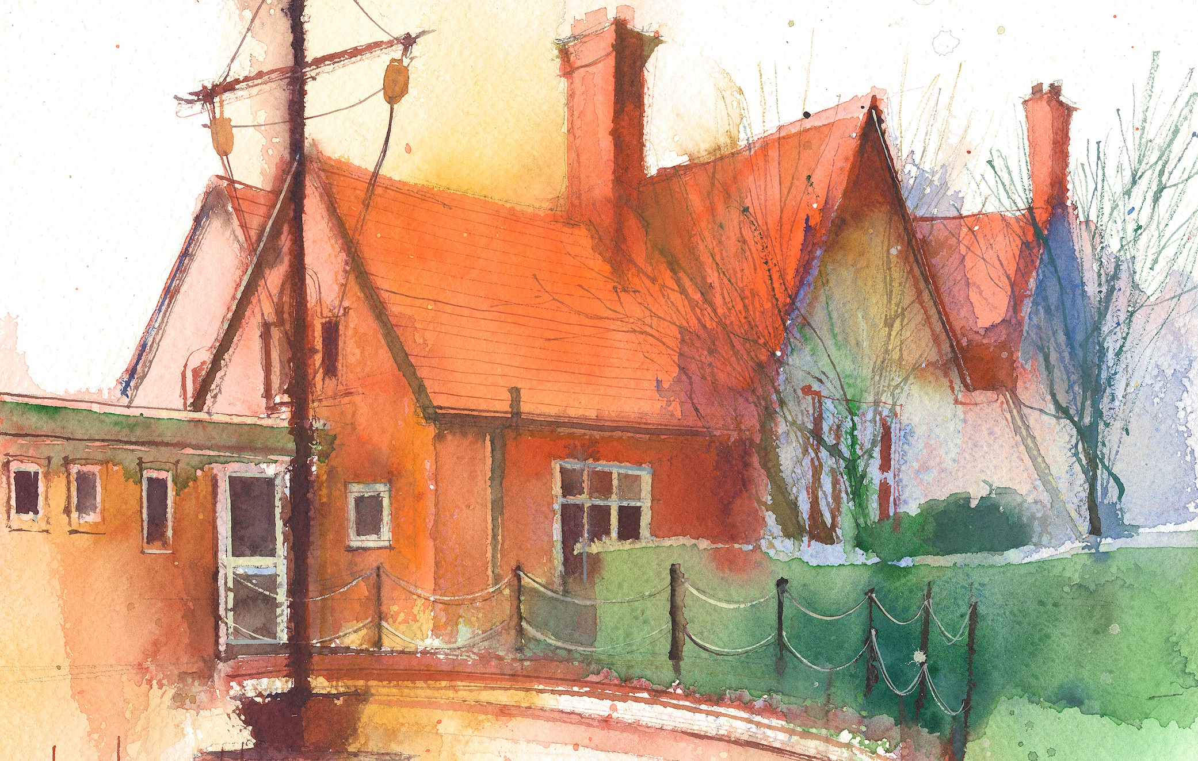

Phase 1: Aspect 6 - Voice sounds
Main Purpose: To distinguish between the differences in vocal sounds, including oral blending and segmenting. To explore speech sounds. To talk about the different sounds that we can make with our voices.
Revisit/ Review | Introduce sitting skills and explain that we are going to do some investigation in to sounds. What sense/part of our body do we need to use?  Learning cards – good sitting, good looking, good listening, brain boxes on. | Revise sitting and listening skills.  Learning cards – good sitting, good looking, good listening, brain boxes on. | Revise sitting and listening skills.  Learning cards – good sitting, good looking, good listening, brain boxes on. | Revise sitting and listening skills.  Learning cards – good sitting, good looking, good listening, brain boxes on. | Revise sitting and listening skills.  Learning cards – good sitting, good looking, good listening, brain boxes on.
Teach | Mouth movements  Show the children how to make different mouth movements (blowing, sucking, tongue stretching and wiggling)  Use a mirror to look at the mouth movement and encourage children to make the movements in the adult’s mirror. | Voice Sounds  Show the children how to make sounds with their voices.  (whee, boing, oh, ssss, shshsh, mmmooo, oooooo, chchchch, zzzz, and tick tock. | Magic Microphone (own resource) or Metal Mike  Have a collection of objects/pictures in a bag and sound out and blend the sounds. Say some of them wrong to encourage the children to join in | Whose voice?  Play a tape of children’s recorded voices. Can they recognise the child’s voice? | Sound story time  Read a familiar story book (The Three Billy Goats Gruff) and change voice for different characters. Use loud, quiet, soft, hard intonation etc.
Practise | Children practise making mouth movements using a mirror. | The children practise making the voice sounds. | Each child takes in turn to find an object/picture and say the sounds. | Re-play the tape and encourage children to listen. | Encourage children to join in with the story and change their voice to match the different characters.

